JOMO KENYATTA UNIVERSITY OF AGRICULTURE AND TECHNOLOGY.
FORECASTING FOREIGN EXCHANGE RATES USING E-GARCH MODEL
A CASE STUDY OF KES/USD, EUR.

KATHURE BESSY MUKARIA SCM215-1945/2015
DALMAS CYNTHIA AKINYI SCM215-1936/2015
MIGWI KELVIN THIGA SCM215-1963/2015
THOMAS KAMAU SCM215-1940/2015

This project is submitted to the Department of Statistics and Actuarial Science in the school of Mathematical sciences in partial fulfillment of the requirement for the award of Degree of Bachelor of science in statistics of Jomo Kenyatta University of Agriculture and Technology.

DECLARATION
We declare that this work has never before been submitted for an approval and award of degree either in this institute or any other. To the best of our knowledge and belief, this research project is our original work except where the references has been made due in the project.

Signature………………….Date……………..KATHURE BESSY MUKARIA
(SCM215- 1945/2015)
Signature…………………..Date…………….DALMAS CYNTHIA AKINYI
(SCM215-1936/2015)
Signature…………………..Date……………..THIGA KELVIN MIGWI
(SCM215-1963/2015)
Signature…………………..Date………………THOMAS KAMAU
(SCM215-1940/2015)

ABSTRACT
Foreign exchange rates modelling and forecasting are vital techniques in terms of foreign trade profit optimization. This is because traders can achieve a higher profit margin by improving forecasting accuracy. The foreign exchange rates have been studied extensively and proved to be effectively forecasted by monetary, and ARIMA models, the volatility effect in foreign exchange rates was seldom mentioned. In this study, an E-GARCH model building procedure is proposed to show that volatility effect appearing in foreign exchange rates can be forecasted using the E-GARCH model. This would help to come up with a better forecast of the conditional mean and the conditional heteroscedasticity. Our proposed procedure combines several parameter evaluation criteria such as Akaike’s information criterion (AIC) and Bayesian information criterion (BIC). Forecasting performance evaluation such as Mean absolute error (MAE), Mean forecast error (MFE) and Mean absolute percentage error (MAPE) has also been covered in this study. Descriptive statistics have also been explained through various plots of Autocorrelation function, quartile-quartile (QQ) plots. This study illustrates that the foreign exchange rates can be better modelled and forecasted by applying E-GARCH model based on multiplicative non-seasonal ARIMA model.

Table of Contents
DECLARATION ii
ABSTRACT iii
LIST OF FIGURES vii
ABBREVIATIONS AND ACRONYMS viii
CHAPTER ONE 1
INTRODUCTION 1
1.0 Background of the study 1
1.1 Overview of domestic currency price determination 3
1.2 PROBLEM STATEMENT 4
1.3 JUSTIFICATION OF STUDY. 5
1.4 OBJECTIVES 6
1.4.1 General objective 6
CHAPTER TWO 7
LITERATURE REVIEW 7
CHAPTER THREE 14
METHODOLOGY 14
3.1 Introduction. 14
3.2 TESTS CONDUCTED PRIOR TO MODELLING, 15
3.2.1 TESTING FOR AUTOCORRELATION 15
3.2.2 TESTING FOR NORMALITY OF THE DATA: 15
3.2.3 SHAPIRO-WILK’S TEST: 15
3.3 REVIEW OF SOME TIME SERIES MODELS 16
3.3.2 AUTOREGRESSIVE MODEL (AR). 18
3.3.3 MOVING AVERAGE (MA). 18
3.3.4 AUTOREGRESSIVE MOVING AVERAGE (ARMA). 18
3.3.5 AUTOREGRESSIVE INTEGRATED MOVING AVERAGE. (ARIMA). 18
3.4 FITTING THE E-GARCH MODEL 19
3.4.1 ARIMA MODEL FITTING PROCEDURE 19
Step1: Examination of the time series plot. 19
Step2: Examination of correlogram. 19
Step 3: Determining the MA-order from ACF and the AR-order from the PACF. 19
Step 4: estimation of ARIMA model parameters. 20
3.4.2 CONDITIONAL HETEROSCEDASTICITY EFFECTS TEST. 20
3.4.3 THE GARCH MODEL. 21
3.4.4 THE AUTOREGRESSIVE CONDITIONAL HETEROSCEDASTICITY (ARCH) MODEL 22
3.4.5 MODEL IDENTIFICATION 23
3.4.6 ESTIMATION OF GARCH PARAMETERS. 23
3.4.8 THE E-GARCH MODEL 23
3.4.9 MODEL IDENTIFICATION 24
3.4.10 PARAMETER ESTIMATION. 25
3.4.11 E-GARCH MODEL FOR FORECASTING THE CURRENCY PRICES. 25
3.5 STUDYING THE PROPERTIES OF THE FITTED MODEL. 25
3.5.1 ASSYMETRIC EFFECTS TEST 25
3.5.2 ARCH EFFECT 25
3.6 FORECASTING THE FOREIGN EXCHANGE RATES: KES/USD, EUR 25
3.7 TESTING THE FORECASTING POWER OF THE FITTED E-GARCH MODEL. 26
CHAPTER FOUR 28
EMPERICAL STUDY 28
4.0 FOREIGN EXCHANGE CURRENCY RATES HISTORICAL DATA. 28
Sample data for 9 trading days 28
4.0.1 DATA ANALYSIS USING USD_KES AND EUR_KES FOREIGN EXCHANGE RATES HISTORICAL DATA. 31
DESCRIPTIVE STATISTICS FROM THE DATA. 33
TESTS OF AUTOCORRELATION. 36
ADF TEST OF STATIONARITY. 37
a. Using usd_kes data. 37
b. Using eur_kes data. 38
4.1 DESCRIPTIVE STATISTICS OF THE RETURN SERIES. 42
4.2 ESTIMATING PARAMETERS AND FITTING THE E-GARCH MODEL TO THE FOREIGN EXCHANGE DATA. 44
4.2.1 THE ARIMA MODEL FITTING PROCEDURE 44
4.2.2 FITTING AN ARIMA MODEL. 46
Testing for Conditional Heteroscedacity. 53
4.2.3 FITTING GARCH (1, 1) MODEL. 55
Sign bias test on GARCH model 55
4.2.4 FITTING THE E-GARCH MODEL. 56
4.3 STUDYING THE PROPERTIES OF THE FITTED MODEL 57
4.3.1 VOLATILITY 57
4.3.4 THE SIGN BIAS TEST. 61
4.3.5 NORMALITY 62
4.4 MULTI-STEP AHEAD FORECAST OF FOREIGN EXCHANGE USING THE E-GARCH MODEL. 65
Forecast of the in-sample 66
Out of sample forecasts. 68
4.4.1VALIDATION OF THE DISTRIBUTION OF THE FORECASTED AND THE ACTUAL EXCHANGE RATES. 72
4.5 TESTING THE FORECASTING P0WER OF THE FITTED MODEL 74
CHAPTER FIVE 75
CONCLUSION. 75
RECOMMENDATION 76
WORK PLAN 77
BUDGET 78

LIST OF FIGURES
Figure 4. 1 Time Plots 31
Figure 4. 2 Box plots of Data 34
Figure 4. 3 The ACF and PACF Plots 35
Figure 4. 4 Time plots of returns 38
Figure 4. 5 ACF and PACF of the returns 39
Figure 4.6 QQ Plots of data 42
Figure 4.7 ACF and PACF Plots of the residuals 46
Figure 4. 8 Actual vs Forecasted rates using ARIMA Model 48
Figure 4. 9 Diagnostic plots of the standardized residuals of USD_KES Returns 50
Figure 4. 10 Plots of standardized residuals of EUR_KES Returns 51
Figure 4. 11 ACF and PACF of the squared residuals 52
Figure 4. 12 ACF Plots of residuals of fitted USD_KES E-GARCH Model 58
Figure 4. 13 ACF Plots of residuals of fitted EUR_KES E-GARCH Model 59
Figure 4. 14 Density plots of the Residuals 62
Figure 4. 15 QQ Plots of the residuals of the E-GARCH Models 63
Figure 4. 16 In sample forecast plots for USD_KES 65
Figure 4. 17 In sample Forecast plots for the EUR_KES 66
Figure 4. 18 Out of sample Forecast for USD_KES 67
Figure 4. 19 Out of sample forecast for EUR_KES 68
Figure 4. 20 Box plots of forecasted Confidence and the Actual USD_KES 69
Figure 4. 21 Box plots of forecasted Confidence and the Actual EUR_KES 70
Figure 4. 22 Density plots of forecasted and actual USD_KES 71
Figure 4. 23 Density plots of forecasted and actual EUR_KES 72

ABBREVIATIONS AND ACRONYMS

KES Kenya shilling.
EUR Euro.
USD United states dollar
S&P 500 Standard and poor 500 index.
ARCH Autoregressive conditional heteroscedasticity.
GARCH Generalized autoregressive conditional heteroscedasticity.
ARCH Autoregressive conditional heteroscedasticity
ARIMA Autoregressive Integrated Moving Average.
MAPE Mean absolute percentage error
MAE Mean absolute error
MFE Mean forecast error

CHAPTER ONE

INTRODUCTION

1.0 Background of the study
According to (jersey, 2008), Foreign exchange market is the market in which foreign exchange rates are determined. Foreign exchange rates are the mechanisms by which currencies are tied together in a global market providing the price of a currency in terms of another currency. An exchange rate is specifically the relative price of two currencies. Forex exchange is the generic term for the global institutions that exist to exchange or trade the currencies of different countries. It is classified into two tiers retail tier and the wholesale tier.
The retail tier is where small agents trade. The wholesale tier is the informal, geographically dispersed network of about 2,000 banks and brokerage firms that mainly deal with each other and also with large firms and corporations. The exchange market is open 24 hours a day divided over three time zones. The foreign exchange begins each day in Sydney and moves around the world as business day begins in each financial Centre. First to Tokyo, London and New York. Computer screens around the world continuously display exchange rate prices. A trader enters the price for the USD/KES for example on his/her machine and then can receive a message from anywhere in the world from people willing to meet that price. The foreign exchange market does not have a physical venue where traders meet to deal in currencies.
Amongst all the financial markets in the world, currency markets are the largest. In the last triennial survey conducted by the Bank of international settlements (BIS) in April 2013. It was estimated that the average daily volume of trading of the foreign exchange market spot, forward and the swap was close to USD 5.3 TRILLION-a 24% increase compared to April 2010. The daily average output is about ten times the daily volumes of the world's equity market and sixty times the US daily GDP. The exchange market daily turnover is also equal to 40percent of the combined reserves of all central banks of IMF member states. In April 2016, major markets were London with 36.97 percent daily volume. New York (19.5percent). Singapore (7.9percent), Hong Kong (6.7percent), Tokyo (6.1percent) and Zurich (2.4percent). Frankfurt, Paris and Amsterdam are small players. The top traded currency was USD, which was involved in 88percent of transactions. It was followed by EUR (31percent), the JPY (22 per cent), and the GBP (13 per cent). The USD and EUR was by far the most traded pair in 2016 and captured 23 per cent of the global turnover, followed by USD and JPY with 18 per cent and USD and GBP with 9 per cent. Trading in the local currencies in emerging markets captured about 21percent of foreign exchange transactions in 2016. Given the global nature of the market, the majority (57percent) of all foreign exchange transactions involves cross-border counterparties. Therefore, this highlights one of the main concerns in the foreign exchange market (counterparty risk). Hence a good settlement and clearing system is needed.
According to (Salvatore, 1998). The most common type of forex transaction includes the payment and the receiving of the foreign exchange within two days of business after the day of the transaction is agreed upon. The two-day period gives adequate time for the parties involved to send instructions to debit and credit the appropriate account. This is called spot transaction. Besides spot transactions, there are forward transactions that involve an agreement today to trade a certain amount of foreign currency at a specified future date at a rate agreed upon today. Forward exchange rates can be used as predictors of future spot rates

1.1 Overview of domestic currency price determination

Like any other market, demand and supply determine the price of the currency. According to (Jersey, 1980) at any point in time, in a given country, the interaction of demand and the supply of foreign currency usually determine the price of a particular currency. Therefore, the exchange rate is an equilibrium price determined by supply and demand considerations. Generally, the determinants of currency supply and demand derive from foreign residents purchasing domestic goods and services through domestic exports whereby investors need domestic currency to pay for their domestic purchases. Similarly, demand for foreign currencies derives from domestic residents purchasing foreign goods and services through importation and tourists travelling abroad. Over time, the many variables, for instance, suppose interest rates increase in the domestic country, ceteris paribus, relative to those in the foreign country, the demand for foreign bonds in the domestic country will decrease, which in turn will reduce the demand for foreign currency in the foreign exchange market. The foreign demand for domestic bonds will consequently increase, causing an increment to the supply of foreign currency in the foreign exchange market. As a result of these movements in the demand and the supply curves in the foreign exchange market, the price of foreign currency in comparison with the domestic currency will decrease. The variables that affect foreign trade, tourism and international investments will change forcing exchange rates to adjust to a new equilibrium. Therefore, movements of the demand and the supply curves in the exchange market, the price of the foreign currency compared to that of domestic currency will decrease. Therefore, the equilibrium price is the exchange rate of the domestic currency.

1.2 PROBLEM STATEMENT
Risk arises every time actual outcomes differ from expected ones. In the foreign exchange market, there is foreign exchange risk when the actual exchange rate differs from the expected exchange rate. According to (Mark & Sul, 2001),monetary models have a small amount of statistical significance in predictability. .Money demand equations used in the monetary model have been proven unstable, especially in the United States (Friedman & Kuttner, 1992). The monetary model is intuitively appealing but clearly explains minimal exchange rate variability. One explanation for weak relation is that exchange rates are intuitively insensitive to monetary fundamentals close to equilibrium values but tends to strongly revert to those deviations when the deviation is large(Taylor & Peel, 2000). Thus the need to develop a stable model to forecast future foreign exchange can help reduce the frustration caused to investors because this inference is core in planning (Taylor, Peel, & Sarno, 2001)investigate the plausibility of this characterization with non-linear models. Therefore, the study adopted E-GARCH model to solve the above problem.

1.3 JUSTIFICATION OF STUDY.
The purpose of this study is to successfully minimize the risk of loss due to the variation in the actual exchange rate and the expected exchange rate. The risk arises as a result of poor planning due to reliance on inaccurate forecast inference.

Theoretically, the study will help the investors in that;
Forecast of exchange rate movements is useful when making a range of decisions in business, mainly if it includes moving into markets where natural hedges may not be available. Financial assessors will also need to assess the accompanying requirements for funding and short-term investments.
Making speculation and hedging decisions.
Hedging is defined as the act averting of a foreign exchange risk or covering of an open position. Speculation is the opposite of hedging. Whereas a hedger seeks to cover risk, a speculator accepts and even seeks out an exchange risk or an open position with the hope of making a profit. Forecasts can be helpful when assessing hedging and speculation strategies. Hedging strategies usually depend on external factors as well as the internal requirements of a business. In recent years, there have been many huge losses incurred by speculation of the movement of exchange rates, and given the increased fluctuations in the exchange rates, an investor can reap good profits with an accurate forecast.
Establishing foreign exchange rates volatility.
Forecasting is also crucial in identifying exchange rate volatility. This volatility may have a significant impact on the foreign currency earnings of a company. This may not be a challenge in the long term if investors understand the effect. However, it will have an impact on the hedging plans of the company.
Exporters and importers.
Forecasting will help the investors whom import and export to make a decision when is the best time to import or export.

1.4 OBJECTIVES

1.4.1 General objective
To forecast foreign exchange rates using E-GARCH model.
1.4.2 Specific objectives
- To obtain descriptive statistics for the return series of KES_USD/EUR.
- To estimate the parameters of an E-GARCH model and fit an appropriate model to the foreign exchange rates data.
- To study the properties of the fitted model(volatility, asymmetric effects, normality)
- Multi-step ahead forecasts using the fitted models for KES_USD/EUR data.
- To test the forecasting power of the fitted E-GARCH model using MAPE, MAE, and MFE.

CHAPTER TWO

LITERATURE REVIEW
2.1 Background
Most businesses in Kenya such as manufacturing, stock exchange, tourism, petroleum import products and services often using KES/USD, EUR exchange rates as it is accepted as a global exchange currency. A weak shilling makes the Kenyan goods and services cheaper in the international market making imports more expensive thus exporters benefit while importers lose. Conversely, a strong shilling makes our goods and services expensive in the international market and makes our imports more affordable, in this case, importers gain while exporters lose. According to a survey done by Central Bank of Kenya (CBK) in the year 2008 its imperative to have an excellent time series model to approximate exchange rate value at a time (t) in the future. This puts into consideration the significant share means that the country’s business transaction are pegged on the US Dollar and the Euro. Any depreciation or appreciation has an impact on the Kenyan shilling. (Holmes, 2008) Found that exchange rate depreciation was inflationary although the impact could not prevail over the gains from increased external competitiveness. The effect of depreciation is that it reduces the real value of assets dominated in the local currency and increases the real value of foreign currency dominated assets.
2.2 Descriptive statistics of return series
There are numbers of reasons for studying time series. These include characterization of time series (or signals), understanding and modeling the data generating system, forecasting of future values and optimal control of a system [Madsen 2007]. In the area of economics, time series analyses are used usually for: economic forecasting, sales forecasting, stock market analysis, yield projections, inventory studies, budgetary studies and real estate market analysis. Issues related to the time series have been the subject of many studies, among others Chatfield [1975], Kendall [1976], Lange [1975], Zeliaś [1984], Milo [1990] and Trojanek [2008].
According to Madsen [2007], time series analysis deal with statistical methods for analyzing and modeling an ordered sequence of observations. This modeling results in a stochastic process model for the system which generated the data. The ordering of observations is most often, but not always, through time, particularly in terms of equally spaced time intervals. The strength of relations and the inertia of stochastic processes can be characterized using joint distribution of random variables and statistical descriptors, for example: mean, variance, and auto covariance. Depending on the way the distribution parameters evolve, one can distinguish between various stochastic processes. One of the most basic methods of describing the series of data, is to check whether it is stationary (either strongly or weakly), or non-stationary.
2.3 Estimation of parameters and fitting of the model
Financial series are characterized by clustered periods of high volatility followed by periods that have low volatility. This idea led to the fact that clustering can be predicted. The Autoregressive conditional heteroscedastic (ARCH) by (Engle, 1982a) and Generalized Autoregressive Heteroscedastic (GARCH) by (Bollerslev, 1986) models are outstanding in predicting this volatility than conventional statistical methods. In classical GARCH models, the conditional variances expressed as a linear function of the squared past values of the series. This particular specification can capture the main stylized facts characterizing financial series. According to (Smith, 1990) volatility in prices has implications on profits and survival of business enterprises as most industries depend on imports and exports. Neither the classic linear AR/ARIMA processes nor non-linear generalization can fulfil this task, but the use of GARCH model that replicate stylized facts appropriately as it provides an accurate assessment of variances and covariance through its ability to model time-varying conditional variances (Jurgen, 2008).
Time series data is data that contains series of data point’s index in time order. Different methods in time series are used to forecast time series data. This includes Autoregressive (AR), Moving average (MA), Autoregressive Moving Average ARMA and ARIMA.
There are many kinds of research about forecasting foreign exchange rate that has been carried out in the world. Until now, there a lot of forecasting models and each model possesses private strong points as well as private weak points.(Tseng et al., 2001), used ARIMA model to forecast future exchange rates.
(Meyer, 1998) Used ARIMA model to forecast inflation Irish, (Mondal, 2014)used ARIMA model for forecasting stock prices. ARIMA is also used in forecasting the price of (Bandyopadhyay, 2016). With object being foreign exchange rates, ARIMA is also a good solution for prediction. Some authors used it forecasting such as (Appiah, S.T, & Adetunde, 2011).
ARIMA models have been applied in forecasting different types of time series and have been compared by a benchmark model for its validity. (Leseps&Morell, 1997)In their study found that the exchange rates follow a long-term trend with the short term fluctuation. Therefore, to capture the long-term trend, many authors had used ARIMA model as proposed by Box-Jenkins (1976), to forecast the exchange rates.

A new pre-differencing and transformation of the ARIMA model for forecasting standard and Poor's (S&P 500) index volatility (Chenn, 1995).The out of sample forecast performance of the GARCH model and the mean reversion model was compared to that of the ARMA model using the pre differencing transformation. It was found that the ARIMA model using the pre-differencing was superior to the mean reversion model and GARCH model in forecasting monthly S&P 500 index volatility for the forecast comparison periods used in this study.
(McAlcer, 2002)Various ARIMA models over the period 1975(1)-1989(4) for tourists' arrivals to Australia and from Malaysia and Singapore. The fitted ARIMA model was found to be valid when the tourist arrivals were forecasted for Singapore for the time period 1990(1)-1996(4).
(Mahadevan, 2002) Found that while forecasting 10-year government securities yield, ARIMA had better accuracy than that of the moving average (MA) model in a static forecast, whereas the lagged moving averages for the 10-year government security outperforms ARIMA model in dynamic forecasting.
The ARCH And GARCH (p, q) was introduced by (Bollerslev, 1986) and (Engle, 1982b) to model the fluctuation of the variances of the time series data. The literature shows that attempts have been made to forecast returns or volatility using conditional heteroscedastic-based models. Engle suggests ARCH and GARCH provide a better forecast of variance. To model foreign exchange, ARCH and GARCH have been proved to be the best due to heteroscedastic nature of the daily foreign exchange rates. Financial time series is said to have volatility clustering effect, and hence conditional heteroscedastic models are being used to develop a more robust model for forecasting.
(Kearns&Pagan, 1991)Examined the monthly volatility of the Australian stock market over the period 1875-1987 and fitted ARCH and GARCH models to the data. It was found that GARCH (1, 1) out-performed the ARCH model for forecasting volatility of returns.
(Brooks&Lee, 1997) Used ARCH/GARCH models to investigate Australian financial futures data. The study was interested in establishing the extent to which the parameters of the model changeover time in which the data was examined by analyzing. It was established that the results to vary over time and simple models such as the ARCH (1) model provides a good fit to the data.
(Tabak&Guetra, 2002) Examined the relationship between stock returns and volatility for June 1990 to April 2002. The relationship between the stock returns and volatility was tested using seemingly unrelated regression method and AR (1)-GARCH (1, 1) estimation. They concluded that using seemingly unrelated regression (SUR) methodology and AR (1)-GARCH (1, 1) estimation. Changes in volatility were established to be negatively related to stock returns.
According to (Radha, 2008)the ARIMA model and random walk are not a good fit. On short-term interest rate forecasting, the results of this study indicate that short-term interest rates have volatility clustering effect in the time series which is captured by the GARCH model. The comparison of models for forecasting short-term interest rates implicit Yield on 91- day Treasury bill shows that ARIMA-GARCH is an appropriate model for forecasting accurately.
According to (Maana, 2010), GARCH (1, 1) was used in the estimation of volatility in the Kenyan exchange rate data from 1993 to 2006. Explanatory data analysis showed that the exchange rates are leptokurtic and positively skewed implying that exchange rate depreciation was experienced during the period probably to ensure that Kenyans exports remained competitive. This study confirms that GARCH (1, 1) fitted the returns well.
Correctly, constructed foreign exchange enables a market participant to gain proceeds from speculative or arbitrage investment and are used in the process of currency risk management, (Engle, 2001) evaluated the performance of nine alternative models; random walk, historical average, moving average, simple regression, exponential smoothing, exponential weighted moving average, the ARCH and the GARCH. He concluded that the ARCH-type models perform well or poorly depending on the form chosen. The performance of GARCH (3, 2) which is the best model within the ARCH family, is sensitive to the choice of assessment measures. The regression and exponentially moving average do not perform well to any assessment measure.
According to(Nelson & Cao, 1992), the GARCH model does not allow Asymmetric effects between positive and negative shocks on conditional variance of future observations, in that it assumes that positive and negative shocks have the same effect on volatility because it depends on the square of the previous shocks. In practice, it is well known that the foreign exchange rates will respond differently to positive and negative shocks.

According to (Bollerslev, Engle, & Nelson, 1994a) propose that the GARCH model experience the same problems as the ARCH-model. For instance, it responds equally to both the negative and the positive shocks. Besides recent empirical studies indicate that the tail behavior of the GARCH-model remains too short even with standardized student t-innovations. The E-GARCH model solves the above weakness.
2.5 Studying the properties of the fitted model
Ahmedet al. (2011) investigated the volatility using daily data from two Middle East stock indices viz., the Egyptian CMA index and the Israeli tase-100 index and used ARCH, GARCH, EGARCH, TGARCH, Asymmetric Component GARCH (AGARCH) and Power GARCH (PGARCH). Their study showed that EGARCH is the best fit model among the other models for measuring volatility. Few models have been limited to at studies only symmetric models. Karmakar (2005) estimated volatility model which is the feature of Indian stock market Emenike Kalu O et al. (2012) who analysed the effects of response of positive and negative shocks of volatility stock returns of the daily closing price of Nigeria Stock Market Exchange (NSE) from January 2nd 1996 to December 30th 2011. Suliman Zakaria (2012) developed a model which measure the volatility in the Saudi Stock Market (TASI INDEX). He introduced many types of asymmetric GARCH models, such models are EGARCH, TGARCH and PGARCH. His studies explained that the positive correlation hypothesis which is the positive relation between the expected stock return and volatility has favour towards the conditional volatility. Hojatallah Goudarzi (2009) studied asymmetric effects which occurred in the stock market, they used ARCH model measured the effects of good and bad news on volatility in the India stock markets during the period of global financial crisis of 2008-09. There are two models EGARCH and TGARCH which are estimated asymmetric volatility. The BSE500stock index was used as a proxy to the Indian stock market to study the asymmetric volatility
Over 10 year’s period. They investigated a growing and increasingly complex market-oriented economy, and the global finance will need more efficient deep and in well – regulated financial markets. Saurabh Singh and Dr. L.K Tripathi (2013) have study the symmetric and asymmetric GARCH models which are estimated for the daily closing prices of Nifty index for fifteen years are collected and estimated by four different GARCH models that capture the conditional volatility and leverage effects. Their study shows the relationship between positive and negative shocks or innovations but asymmetric negative effect is greater than the positive.
2.4 Multistep ahead forecast
Ederington and Guan (2005) compared the following four attributes of the existing models the relative weighting of recent vis-a-vis older observations the estimation criterion the trade-off in terms of out-of-sample forecasting error between simple and complex models the emphasis placed on large shocks. They observed that GARCH (1, 1) yields better forecasts than the historical standard deviation and exponentially weighted moving average models. They developed and tested a new model- nonlinear least squares model, based on historical absolute return deviations, perform better in terms of forecast accuracy.
Karmakar M. (2005) estimated conditional volatility models in an effort to capture the salient features of stock market volatility in India and evaluated the models in terms of out-of sample forecast accuracy. The estimation of volatility has been made at the macro level on two major market indices, namely, S&P CNX Nifty and BSE Sensex. The fitted model have been evaluated in terms of its forecasting accuracy on these two indices. Moreover, 50 individual companies share prices included in S&P CNX Nifty have been used to examine the heteroskedastic behavior of the Indian stock market at the micro level. It was observed that the GARCH (1, 1) model provided reasonably good forecasts of market volatility and the GARCH (1, 1) model has been fitted for almost all companies.
Shamiri and Hassan (2005) examines and estimate the three GARCH (1, 1) models (GARCH, EGARCH and GJR-GARCH) using the daily price data of Malaysian and Singaporean stock market. The estimation results show that the forecasting performance of asymmetric GARCH Models (GJR-GARCH and EGARCH), especially when fat-tailed asymmetric densities are taken into account in the conditional volatility, is better than symmetric GARCH. Moreover, it was found that the AR (1)-GJR model provided the best out-of-sample forecast for the Malaysian stock market, while AR(1)-EGARCH provided a better estimation for the Singaporean stock market.
2.5 Testing the forecasting power
(Duzgun, 2008) used Mean absolute error(MAE), mean sum of errors(MSE) and RMSE (Root mean square error) and the Thiel's U-test to compare ARIMA with ANN models using the data from 1987-2007. The results indicated that the ARIMA model was better than the Artificial Neural networks (ANN) for forecasting the gross domestic product (GDP) of the Turkish Economy.

CHAPTER THREE

METHODOLOGY

3.1 Introduction.
The following chapter discusses the research design which was implemented, the population, the sample and the type of data which will be used. Further, this chapter explains how data was analyzed and how the conclusion was made.
Empirical research design was applied in this research since it is the most relevant form for time series data analysis. It also allows the behavior of the time series data, which will be sampled at a regular interval, to be studied before a particular model can be applied to analyze the data. Therefore, the empirical methodology helps to avoid the possibility of generating wrong results and conclusions.
In order to obtain the best results, an eleven -year historical data (2007-2018) at a different frequency daily return for each currency will be collected and tested and the model fitted on each of the data set. The following is the list of currencies that was included in the sample;
List of currencies
CURRENCY NAME: SYMBOL
KENYA SHILLING KES.
UNITED STATES DOLLAR USD.
THE EURO EUR.
Data was taken from investing.com website for the period of eleven years (2007-2018), that is from Monday to Friday only on trading days. The choice of US dollar and EURO is based on their relative proportions in the bank's foreign reserve portfolio. The currencies are the leading in the composition of Kenya's imports. The secondary data from investing.com website was stored in an electronic device (computer with unique password) in which only the principal investigators will be authorized to access to prevent any malicious act like data alteration which may hinder our research. The researchers used hard drives and a flash disk for a back-up in research.

3.2 TESTS CONDUCTED PRIOR TO MODELLING,
Since in this study empirical research design was adopted the following tests will be conducted in order to make modelling effective;

3.2.1 TESTING FOR AUTOCORRELATION
Ljung-Box test was performed to test whether series have significant correlation or not. This test ensures that the data prior to being used to model is random.
The hypothesis:
$H_{0}$: Data are not correlated.
$H_{1}$: Data are correlated (not random)
Therefore, a portmanteau test will be conducted as follows:
 | Q (m) =N (N+2)$\sum_{I=1}^{K}{\frac{σ_{I}^{2}}{N-1}}$ | (3. 1)

N=sample size.
$σ_{k}^{2}$ =sample autocorrelation at lag k.
The null hypothesis is rejected at $α$ level of significance if
Q (m)>chi-square tabulated at (1-$α$, k) where k is the degrees of freedom.

3.2.2 TESTING FOR NORMALITY OF THE DATA:
The QQ-plots: It tests normality and randomness of data. Normality was checked by plotting the QQ-plot versus the theoretical quantiles of the normal distribution.

3.2.3 SHAPIRO-WILK’S TEST:
This was used essentially calculate the correlation between the residuals and the corresponding normal quartiles. The hypothesis to be tested is
$H_{0}$: The data is normally distributed.
$H_{1}$: The data is not normally distributed.
If p-value<$α$ we reject the null hypothesis and conclude that the data is not normal.

3.3 REVIEW OF SOME TIME SERIES MODELS
In this research, the graph of the trend was obtained for the period mentioned. Then a descriptive statistics of the results based on occurrences in Kenya in the period was obtained. To model using time series data, the series has to be stationary to give accurate results and predictions. Time series are either stationary or non-stationary, in the case of stationarity, a time series is considered to be stationary if there is no systematic change in mean or there is no systematic change in variance (no trend). A time series is strict if the joint distribution of is the same as the joint distribution of
$r_{t1}$,$r_{t2}$,$r_{t3}$,…,$r_{tk}$

Is the same as
$r_{t1+h}$+$r_{t2+h}$ +$r_{t3+h}$+…+$r_{tk+h}$
h = distance between one observation and the other.
Shifting the time origin by h does not affect the joint distribution which must only depend on the time interval between${ t}_{1}$,$t_{2}$,…,$t_{k}$
Consider the model
 | $r_{t}$=$α r_{t-1}$+$a_{t}$for t=1, 2 | (3. 2)

Where $a_{t}$ is a stationary process?
$r_{t}$ Is a non-stationary process if the coefficient if$α$=1
However, it becomes stationary if $\left|α\right|$ <1.
Suppose that ( $r_{t}$) is an AR (p) process.
 | $r_{t}$=c+$φ_{1}r_{t-1}$+$φ_{2}r_{t-2}$+…+$φ_{p}r_{t-p}$+$e_{t}$. | (3. 3)

Hypothesis:
$H_{0}$:$α$=0(the data is not stationary/unit root)
$H_{1}$:$α$<0(the data is stationary/no unit root)
The test statistic is a t-statistic
t=$\frac{α}{s.e(α)}$
Critical value:

Decision rule:
If t >ADF critical value (we do not reject the null hypothesis)
If $t^{*}$<ADF critical value (we reject the null hypothesis)
If the p-value<$α$ reject null hypothesis and conclude the data is not stationary/unit root and hence this will call for differencing. The differencing will make the data stationary.

There are several models employed in time series:
Autoregressive (AR), Moving average (MA), Autoregressive moving average (ARMA), Autoregressive integrated moving average (ARIMA), Generalized autoregressive conditional heteroscedasticity (GARCH), Exponential Generalized autoregressive conditional heteroscedasticity (E-GARCH)
Which was explained under the following subsections.

3.3.2 AUTOREGRESSIVE MODEL (AR).
Autoregressive model of order p, AR (p) defined as
Consider an autoregressive model of order p, AR (p) defined as:
 | ${ r}_{t}$=c+$φ_{1}r_{t-1}$+$φ_{2}r_{t-2}$+…+$φ_{p}r_{t-p}$+$e_{t}$. | (3. 4)

Where $e_{t}$a white noise. This is is a multiple regression with lagged values of $r_{t}$ as predictors.

3.3.3 MOVING AVERAGE (MA).
Consider a moving average model MA (q) defined as
 | $r_{t}$=c+$e_{t}$+$θ_{1}e_{t-1}$+$θ_{2}e_{t-2}$+…+$θ_{q}e_{t-q}$ | (3. 5)
Where $e_{t}$ is a white noise.
This is a multiple regression where past errors are the predictors.

3.3.4 AUTOREGRESSIVE MOVING AVERAGE (ARMA).
 | $r_{t}$=c+$φ_{1}r_{t-1}$+$φ_{2}r_{t-2}$+…+$φ_{p}r_{t-p}$+$θ_{1}e_{t-1}$+$θ_{2}e_{t-2}$+…+$θ_{q}e_{t-q}$+$e_{t}$. | (3. 6)
The predictors of an ARMA (p, q) model includes both lagged values of $r_{t}$ and lagged errors

3.3.5 AUTOREGRESSIVE INTEGRATED MOVING AVERAGE. (ARIMA).
An ARIMA model is considered unit root non-stationarity because its AR polynomial has a unit root. Like random walk model, ARIMA model has strong memory because the $θ_{i}$coefficient in it is moving average representation does not decay to zero, implying that the past shock $e_{t-i}$ of the model has a permanent effect on the series. A conventional approach for handling unit-root non-stationarity is to use differencing.
 | $r_{t}$=c+$φ_{1}$B$r_{t}$+$φ_{2}B^{2}r_{t}$+…+$φ_{p}B^{p}r_{t}$+$e_{t}$-$θ_{1}$B$e_{t}$-$θ_{2}B^{2}e_{t}$-…-$θ_{q}B^{q}e_{t}$ | (3. 7)
Therefore, the ARIMA model is denoted as ARIMA (p, d, q) where AR (p) = order of the Autoregressive part.
I: d= degree of first differencing involved.
MA (q) = order of moving average part.

3.4 FITTING THE E-GARCH MODEL

3.4.1 ARIMA MODEL FITTING PROCEDURE

Step1: Examination of the time series plot.
Our first step shall be to identify a time series plot with a motive to identify apparent trends, seasonal components and any outliers if present. We shall conduct tests to ascertain stationarity Augmented Dickey-Fuller test (ADF) test. These components should be removed through differencing.

Step2: Examination of correlogram.
Trend and seasonal components may show up by plotting correlogram. (A plot of ACF
$ρ_{k}$ Against k)
A slowly dumping correlogram is an indication of a slowly varying trend component.
While a periodic fluctuating correlogram is indicative of a periodic component (with the same period)

Step 3: Determining the MA-order from ACF and the AR-order from the PACF.
If the data appear stationary in both the time-series plot and the correlogram. We will try to identify the AR order from the sample ACF and the MA order from the sample PACF.
The following rule was to be applied:
Denote PACF as $p_{k}$ then
We fit an AR (p) model to the data if
$p_{k}$ $≤$1.96/$√$n
For about 95$\%$ for k’s among all k>p and n is the sample size.
Step 4: Determining the orders using AIC, AICC each method has its Empirical experience suggests that:
AIC=-2*log-likelihood+2p
Alternatively;
BIC is the Bayesian information criterion.
BIC=-2*log-likelihood+p (1+lnN)
The corrected AIC i.e. AICC
 | AICC=AIC+$\frac{2(k+1)(k+2)}{n-k-2}$ | (3. 8)
Where n=sample size.
k = the total number of parameters excluding the white noise.

Step 4: estimation of ARIMA model parameters.
Having identified the model order. The parameters
$c_{t}$,$φ_{1}$,$φ_{2}$,…,$φ_{p}$,$θ_{1}$,$θ_{2}$,…,$θ_{q}$.
Are estimated through the maximum likelihood criterion. Theoretically, the MLE is obtained by minimizing $\sum_{i=1}^{T}{e_{t}^{2}}$ utilising the concept of non-linear optimisation.

3.4.2 CONDITIONAL HETEROSCEDASTICITY EFFECTS TEST.
The ARIMA model major on the conditional mean structure of the time-series data. However, there are cases where there exist inconsistencies between the data and after transformation. For example, we expect that squaring the residuals of the data or even taking the absolute values the ACF's of the data to remain insignificant but any deviations from this would imply that the data highly depends on the structure. In this study, the Ljung box test of squared residuals was used
The hypothesis to be tested included:
$H_{0}$: There is no ARCH effect.
$H_{1}:$ There is an ARCH effect.

The test statistic is compared with chi-square tabulated value with (m-p-q) degrees of freedom. Consequently, the null hypothesis will be rejected if p-value<$α$
Where $α$=level of significance.
N=sample size.
m=number of autocorrelation included in the statistic.
$ρ_{m}^{2}$=sample autocorrelation of residuals series$\left\{e_{i}\right\}$ at lag m.

Moreover, conclude that there is the presence of ARCH effect. Then if this happens, the next step was to model ARCH-effect using conditional heteroscedastic models. The following procedure was adopted:

3.4.3 THE GARCH MODEL.
Modelling the volatility of a time series helps in improving the efficiency in parameter estimation and accuracy in the interval forecast. The model assumes that the conditional mean is already given. However, we estimate conditional mean and variance.
Define;
$α_{t}$ As the shock or the mean corrected return. Of an asset return at time t.
$σ_{t}$ Is the positive root of $σ_{t}^{2}$
The mean equation for
$r_{t}$ And the model $σ_{t}^{2}$ is the volatility equation of $r_{t}$
To build a generalized autoregressive conditional heteroscedastic model consider an ARCH model (Autoregressive conditional heteroscedastic model) which is a fundamental procedure when building the GARCH model

3.4.4 THE AUTOREGRESSIVE CONDITIONAL HETEROSCEDASTICITY (ARCH) MODEL

This is a first model that provides the systematic framework for volatility is the ARCH model of (Engle, 2001) the idea behind the ARCH model is that the mean corrected asset return
$α_{t}$
Is serially uncorrelated but dependent.
The dependence of $α_{t}$ can be described by a simple quadratic function of its lagged values.
The ARCH (q) assumes that:
$α_{t}$=$σ_{t}e_{t}$
 | $σ_{t}^{2}$=$∝_{0}$+$∝_{1}α_{t-1}^{2}$+…+$∝_{m}α_{t-m}^{2}$. | (3. 9)

However, although the ARCH model is simple, it often requires many parameters to describe the volatility process of an asset return adequately. (Bollerslev, 1986) proposes a useful extension known as the generalized ARCH (GARCH). For log returns, we assume that the mean equation of the process can be modelled using the ARIMA model. Therefore consider:
$α_{t}$ =$r_{t}$-$μ_{t}$ be the mean corrected log-return.
$r_{t}$=given time series.
Where $μ_{t}$ is the mean equation of $r_{t}$
$α_{t}$ Follows a GARCH (p, q) model (where p represents the order of the GARCH terms $σ^{2}$ and q is the order of the ARCH terms $α^{2}$
Therefore;
 | $σ_{i}^{2}$ =$∝_{0}$+$\sum_{i=1}^{p}{∝_{i}}a_{t-i}^{2}$+$\sum_{j=1}^{q}{β_{j}}σ_{t-j}^{2}$ | (3. 10)

The lag-length p of GARCH (p, q) is established in three basic steps:
Identification of the best fitting AR (q) model:
$r_{t}$=c+$φ_{1}r_{t-1}$+$φ_{2}r_{t-2}$+…+$φ_{q}r_{t-q}$+$e_{t}$.
 | $r_{t}$ = c + $\sum_{i=1}^{q}{φ_{i}}r_{t-i}$+$e_{t}$ | (3. 11)

3.4.5 MODEL IDENTIFICATION
According to (Bollerslev, 1986), has shown that relatively long lags are required in ARCH model
Therefore, GARCH (1, 1) is usually adequate in describing many financial time series.

3.4.6 ESTIMATION OF GARCH PARAMETERS.
A GARCH model with known orders p$≥$1 and q$≥$0 therefore by the use of Quasi (Gaussian) maximum likelihood we will estimate the parameters of the model.
However, according to (Nelson & Cao, 1992), the GARCH model does not allow Asymmetric effects between positive and negative shocks on conditional variance of future observations in that it assumes that positive and negative shocks have the same effect on volatility. This is foreign exchange rates will respond differently to positive and negative shocks.

3.4.8 THE E-GARCH MODEL
Define
 | $α_{t}$ =$σ_{t}e_{t}$ | (3. 12)
The E-GARCH model is thus defined as;
 | ln ($σ^{2}$) =$(∝_{0}$+$\frac{1+β_{1 B+…+β_{P B^{P}}}}{1-α_{1}B+…+α_{PB^{P}}}$) g ($e_{t-i}$) | (3. 13)

Where
 | g ($e_{t}$) =$\left\{\begin{aligned}\left(θ+γ\right)e_{t-γE\left(\left|e_{t}\right|\right)}ife_{t ≥0} \\ \left(θ-γ\right)e_{t}-γE\left(\left|e_{t)}\right|\right)ife_{t<0}\end{aligned}\right.$ | (3. 14)

B is a backshift operator (or lag) such that
Bg ($e_{t}$) =g ($e_{t-1}$)
The E-GARCH can also be written as:

 | ln ($σ^{2}$) =$α_{0}$+$β$ ln ($σ_{t-1}^{2}$) +$α\left|\frac{e_{t-1}}{\sqrt{σ_{t-1}^{2}}}\right|$+$γ$ $\frac{e_{t-1}}{\sqrt{σ_{t}^{2}}}$ | (3. 15)

This equation implies that the effect of the exponential, rather than the quadratic, and the forecasts of the conditional variance are guaranteed to be non-negative. Hence solving the main weakness of the GARCH model.

3.4.9 MODEL IDENTIFICATION
The Akaike’s information and the Bayesian information criterion are identified as:
AIC =$\sum_{t=1}^{T}{(}logh_{1}$+$e_{t}^{2}h_{t}^{-1}$) +2(p+q+1)
BIC =$\sum_{t=1}^{T}{(h_{1}}$+$e_{t}^{2}h_{t}^{-1}$) +2(p+q+1) log (T-k+1)
Where: $h_{t}$=$σ_{t}^{2}$.

3.4.10 PARAMETER ESTIMATION.
An E- GARCH model with known orders p$≥$1 and q$≥$0 therefore by the use of Quasi (Gaussian) maximum likelihood we will estimate the parameters of the model.

3.4.11 E-GARCH MODEL FOR FORECASTING THE CURRENCY PRICES.
$r_{t}$=c+$φ_{1}$B$r_{t}$+$φ_{2}B^{2}r_{t}$+…+$φ_{p}B^{p}r_{t}$+$e_{t}$-$θ_{1}$B$e_{t}$-$θ_{2}B^{2}e_{t}$-…-$θ_{q}B^{q}e_{t}$+$(∝_{0}$+$\frac{1+β_{1 B+…+β_{P B^{P}}}}{1-α_{1}B+…+α_{PB^{P}}}$)g
($e_{t-i}$) | (3. 16)
Which contains the mean forecast and forecast of the conditional variance.

3.5 STUDYING THE PROPERTIES OF THE FITTED MODEL.

3.5.1 ASSYMETRIC EFFECTS TEST
The test hypothesis was:
$H_{0}$: There is asymmetric effects due to positive and negative shocks.
$H_{1}$: There is no asymmetric effects due to positive and negative shocks

3.5.2 ARCH EFFECT
The residuals of the fitted model were examined in order to check if there was existent higher order auto-correlation. In both cases the ACF and the PACF of the standardized, squared and absolute residuals were plotted in order to examine serial dependence.

3.6 FORECASTING THE FOREIGN EXCHANGE RATES: KES/USD, EUR
Then the study used E-GARCH model multiple-step ahead forecasts as follows:
Assuming the model parameters are known, and the innovations are standard Gaussian then consider an E-GARCH (p, q)
Which can be represented as;
 | ln ($σ^{2}$) =$(∝_{0}$+$\frac{1+β_{1 B+…+β_{P B^{P}}}}{1-α_{1}B+…+α_{PB^{P}}}$) g ($e_{t-i}$) | (3. 18)

Then a multi-step ahead forecasts will involve first taking the exponential of the model and then take conditional expectation at time t+h. Hence obtaining the forecast of the conditional heteroscedasticity at time t+h.
Therefore in this study assuming that $r_{t}$ is the current price for the Kenya shilling against dollar .then the forecast at a time.
$r_{t+h}$=forecast of the conditional mean (using the ARIMA model at time t+h) + the forecast the forecast of the conditional heteroscedasticity (Using the E-GARCH Model at the time (t+h))

3.7 TESTING THE FORECASTING POWER OF THE FITTED E-GARCH MODEL.
Due to the fundamental importance of time series forecasting in many practical applications particularly in this study on foreign exchange rates, care should be taken when fitting an
E-GARCH model. For this reason, the study intended to first focus on various performance measures proposed in the literature to estimate forecast accuracy and to compare different models and evaluate the performance metrics of the fitted model before forecasting. Each of the measures is a function of the actual and forecasted time series. Each measure has a unique characteristic different from the others and in experiment. This study will consider more than one performance criteria. This would help obtain a reasonable knowledge about the amount, magnitude and direction of overall forecast error, for this reason, analysts prefer more than one measure for judgement. Consider,$y_{t}$ =Actual value and $f_{t}$ =the forecasted value. Then $e_{t}$ =$y_{t}$ ,
n =size of the test. The most common performance metrics include;
1. The mean forecast error (MFE); this measure is defined as;
MFE=$\frac{1}{n}\sum_{t=1}^{n}{e_{t}}$.
It is the measure of the average deviation of forecasted values from actual ones. For a good forecast, it is desirable that MFE be close to zero as possible. The study intended to whether or not this condition holds before forecasting in the long run.
2. Mean absolute error (MAE); the measure has the following mathematical definition;
MAE=$\frac{1}{n}\sum_{t=1}^{n}{\left|e_{t}\right|}$
Its properties include that it measures the average absolute deviation of forecasted values from the original values. It is also termed as Mean absolute deviation (MAD). This study intended to establish whether MAE is as small as possible.
3. The mean absolute percentage error (MAPE); this performance metric is represented as;
MAPE=$\frac{1}{n}\sum_{t=1}^{n}{\left|\frac{e_{t}}{y_{t}}\right|}×$100.
This study will establish whether the fitted model yields Avery small value of MAPE

CHAPTER FOUR

EMPERICAL STUDY

4.0 FOREIGN EXCHANGE CURRENCY RATES HISTORICAL DATA.
The historical data of foreign exchange rates of USD_KES and EUR_KES was collected from investing, com website for a period of 11 years for an average of 252 trading days per year from dates 01/01/2007 to 01/01/2019.

Sample data for 9 trading days

Table 4. 1 :Sample data for USD_KES
Date | Price | Open | High | Low | Change %
1-Jan-19 | 101.9 | 101.9 | 101.9 | 101.9 | 0.00%
31-Dec-18 | 101.9 | 101.8 | 101.97 | 101.75 | 0.00%
30-Dec-18 | 101.9 | 101.9 | 101.9 | 101.9 | 0.00%
28-Dec-18 | 101.9 | 101.82 | 101.9 | 101.73 | 0.10%
27-Dec-18 | 101.8 | 101.8 | 101.9 | 101.7 | -0.05%
26-Dec-18 | 101.85 | 101.85 | 101.85 | 101.85 | 0.10%
25-Dec-18 | 101.75 | 101.75 | 101.75 | 101.75 | 0.00%
24-Dec-18 | 101.75 | 101.75 | 101.9 | 101.7 | 0.00%
23-Dec-18 | 101.75 | 101.75 | 101.75 | 101.75 | 0.00%

Table 4. 2 :Sample data for EUR_KES
Date | Price | Open | High | Low | Change %
1-Jan-19 | 116.815 | 116.835 | 117.685 | 116.425 | -0.06%
31-Dec-18 | 116.88 | 116.61 | 116.88 | 116.27 | 0.25%
30-Dec-18 | 116.59 | 116.59 | 116.59 | 116.59 | -0.01%
28-Dec-18 | 116.605 | 116.355 | 116.895 | 116.285 | 0.21%
27-Dec-18 | 116.365 | 115.685 | 116.635 | 115.655 | 0.64%
26-Dec-18 | 115.63 | 115.62 | 116.23 | 115.49 | 0.01%
25-Dec-18 | 115.615 | 115.995 | 116.295 | 115.595 | -0.32%
24-Dec-18 | 115.99 | 115.64 | 116.33 | 115.43 | 0.24%
23-Dec-18 | 115.71 | 115.71 | 115.71 | 115.71 | 0.00%

From the results above:
The date column shows the trading days’ date in the year (excluding weekends and public holidays)
The price indicates the closing price for USD_KES and EUR_KES at any particular day.
Open indicate the opening price for USD_KES and EUR_KES at any particular day.
High-indicates the highest price achieved by USD_KES and EUR_KES at any particular day.
Low-indicates the lowest price achieved by USD_KES and EUR_KES at any particular day.

Change: indicates the log –returns expressed as a percentage.
Basically a percentage log return /change is calculated as follows:
$∆$% =$\frac{ x_{t}}{x_{t-1}}$*100
In this case;
Let: $x_{t}$ –represent the foreign exchange rate for USD_KES at 01/01/2019.
Therefore
$x_{t}$=101.9
Let:$x_{t-1}$ –represent the foreign exchange rate for USD_KES at 31/12/2018
Therefore
$x_{t-1}$ =101.9
Then let change
$∆$% =$ln({\frac{101.9}{101.9}}$)*100=0.00%
Indicating that the log returns of USD_KES as at 01/01/2019 was 0.00%
Further analysis of the sample data above showed that:
The percentage log returns of USD_KES as at 21-Dec-2018 was 0.35% indicating that the exchange rate appreciated by 0.35% compared to the exchange rate as at 20-Dec-2018.Similarly, the log returns of EUR_KES as at 21-Dec-2018 was -0.30% indicating that the exchange rate for the two currency pairs depreciated by 0.30%.
The percentage log returns of USD_KES as at 23-Dec-2018 to 25-Dec-2018 was 0.00% constant indicating that the exchange rate for the two currency pairs did not appreciate or depreciate thus remained constant. On the other hand, the log returns for the EUR_KES as at 23-Dec-2018 was 0.00% indicating no change in the currency rate on 22-Dec-2018 and 23-Dec-2018. On 24-Dec-2018 the exchange rate for EUR_KES appreciated by 0.24% compared to the exchange rate on 23-Dec-2018.On 25-Dec-2018 the exchange rate for EUR_KES depreciated by 0.32% compared to 24-Dec-2018.
It is therefore clear that for the 10 trading days the foreign exchange rates for USD_KES and EUR_KES depreciated compared to the previous day return whenever the percentage log return was a negative, appreciated whenever the percentage log return was positive and remained constant whenever the percentage log return was 0.00%

4.0.1 DATA ANALYSIS USING USD_KES AND EUR_KES FOREIGN EXCHANGE RATES HISTORICAL DATA.
The exchange rates indicated are represented by the following relationship:
$\frac{USD}{KES}$ =$π$
$\frac{EUR}{KES}$=α
Where $π$ is the daily average exchange rate for USD_KES
Where α is the daily average exchange rate for EUR_KES.
Because of this inverse relationship, if the exchange rate increases it implies that the KES has depreciated and vice-versa. The trend of exchange rates is shown in figure 1 below:
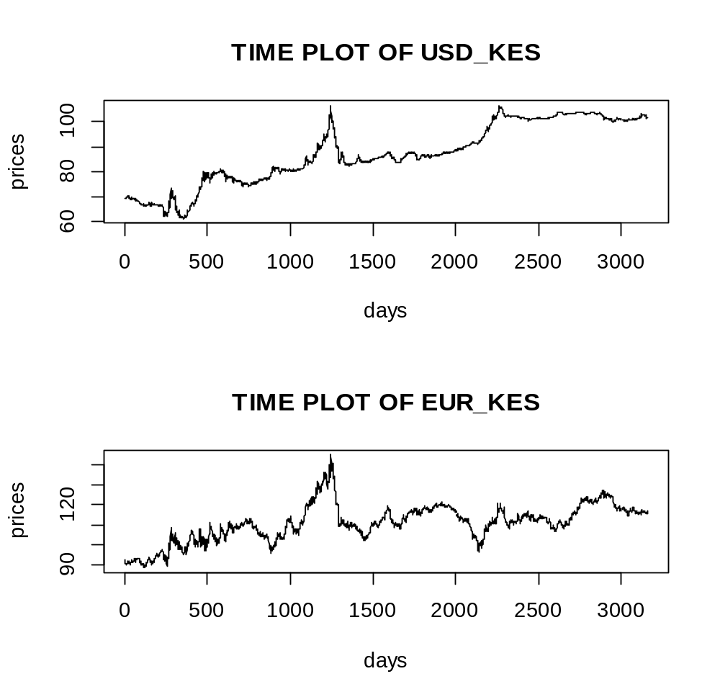
Figure 4. 1 Time Plots
From the figure 4.1, it was deduced that:
The time plot shows that there was a general strengthening of kenya shilling from 01/jan/2013-07/july/2015 .This was attributed to social economic reforms and transformation by the exiting NARC government headed by president Mwai kibaki which came to power in the year 2002 but was exiting on march 2013 when the general election was conducted.In deed, this was the period when the country experienced a peaceful election from the previous 2007 post election violence.In addition there was a new Jubilee government headed by president Uhuru kenyatta which made efforts to create a good political environment in the country.All these made major development partners and donors have a great confidence in the country
There was weakening of kenya shilling period from around 15/july 2015 -jan 2017 due to worsening political environment infact this period was characterized with very high levels of corruption in the country and this discouraged the foreign investment and hence reducing the demand of KES against USD and EUR.
The kenyan shiling worsened further from around jan2017-may2018 this may be due to a series of problems that the economy faced .Some of this problems were like political instability after 2017 elections ,unfavourable climate -a major drought that the country faced in the year 2017 and also the major floods that the country faced in the year 2018.
From june 2018 up to date the kenya shilling is appreciating due to improved political stability thus improving the confidence of the foreign investors

Due to the emphirical research approach adpoted the data had to be studied prior to modelling and the results analyzed as follows:

DESCRIPTIVE STATISTICS FROM THE DATA.
Table 4. 3 :Descriptive statistics of USD_KES Data
STANDARD DEVIATION | 12.24704
MEAN | 87.23215
MEDIAN | 86.4
KURTOSIS | 1.992013

Table 4. 4 Descriptive statistics of EUR_KES data
STANDARD DEVIATION | 9.363862
MEAN | 110.7178
MEDIAN | 111.1025
KURTOSIS | 3.297412

In table 2 above indicates the basic descriptive statistics of the exchange rates. The exchange rate is negatively skewed; for the second case this median is greater than the mean.(positively skewed)
Kurtosis of USD_KES is less than 3.0 implies platykurtic and hence the curve is flatter than the normal distribution bell curve.
Kurtosis of EUR_KES is greater than 3.0 implies leptokurtic and hence the curve is sharper than that of the normal distribution bell curve.
Further summary of the data:
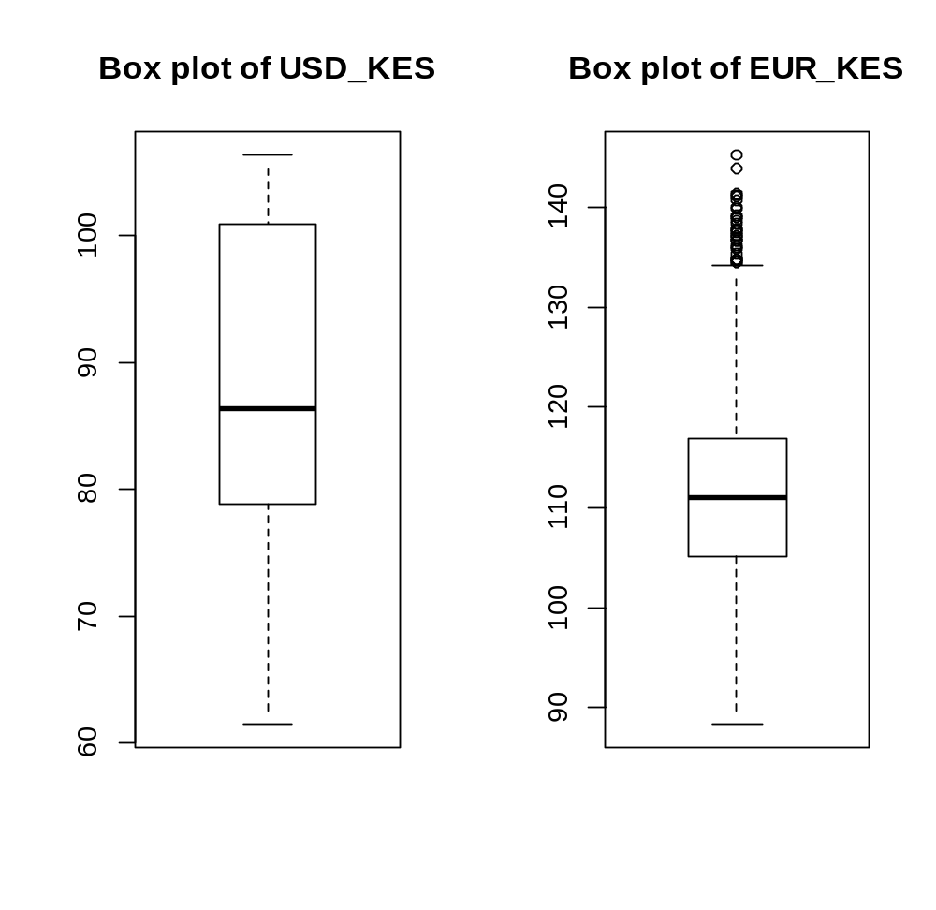
Figure 4. 2 Box plots of Data

TESTS OF AUTOCORRELATION.
This was obtained by obtaining the plots of ACF and PACF and results displayed as follows:

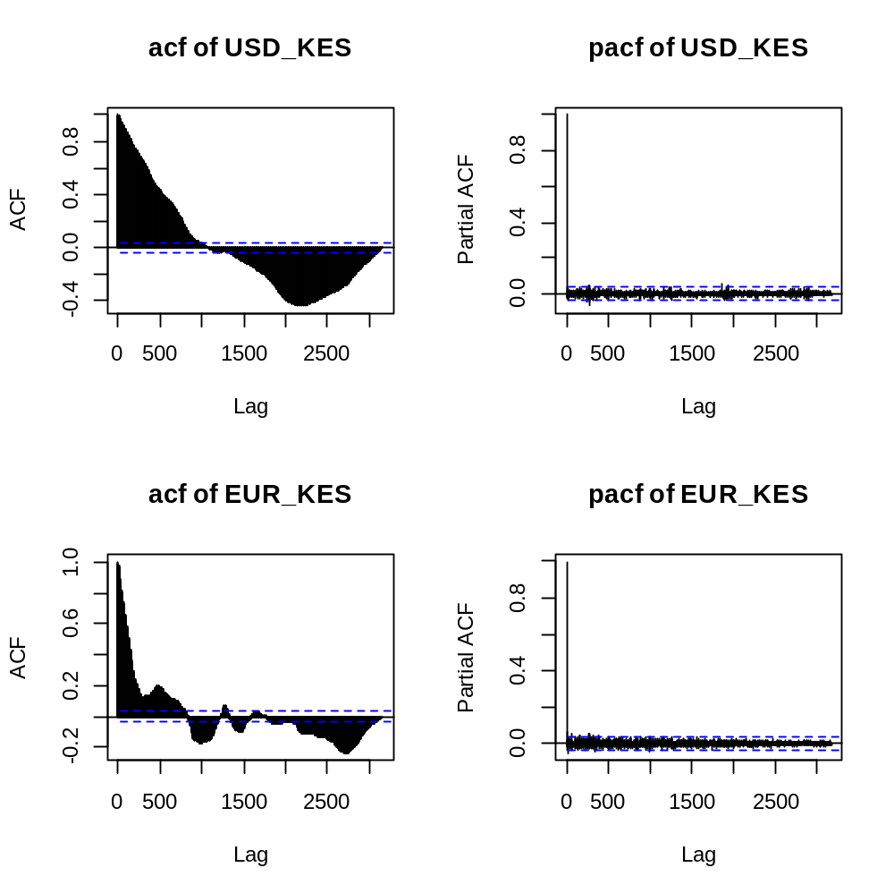
Figure 4. 3 The ACF and PACF Plots
The figure above indicates that the ACF are decaying exponentially, this indicates that the rates are not stationary. For us to do any model fitting on a time series we needed to stationarise the rates. In this case we difference to gain stationarity.
The appropriate AR and MA terms are identified for each of the exchange rate using the ACF and PACF, which indicates the significant lags for the MA and AR terms. Looking at the daily exchange rates means, the ACF is decaying exponentially and the PACF exhibit damped sinusoid. Using this empirical analysis, the prices exhibit AR (p) and MA (q). We therefore formally conducted ADF test for stationarity

ADF TEST OF STATIONARITY.

a. Using usd_kes data.
The following hypothesis was conducted:
$H_{0}$:$α$=0(the data is not stationary/unit root)
$H_{1}$:$α$<0(the data is stationary/no unit root)
The test statistic is a t-statistic
t=$\frac{α}{s.e(α)}$
The following result was obtained
Table 4. 5: ADF test on USD_KES Data
Augmented Dickey-Fuller Test
data: column2
Dickey-Fuller = -2.9192, Lag order = 14, p-value = 0.1892
alternative hypothesis: stationary

Conclusion:
Since the p-value >the level of significance (0.05) we fail to reject the null hypothesis and conclude that the data is not stationary.

b. Using eur_kes data.

Table 4. 6: ADF test on EUR_KES data.
Augmented Dickey-Fuller Test
data: column3
Dickey-Fuller = -3.2174, Lag order = 14, p-value = 0.08488
alternative hypothesis: stationary

Since the p-value >the level of significance we failed to reject the null hypothesis and concluded that the data was not stationary. This calls for a transformation that would make the data stationary. In this case we take first order difference of the natural logarithms of the exchange rates and is determined as:

$R_{t}$ =ln ($\frac{Y_{t}}{Y_{t-1}}$)
Where $Y_{t}$ is the exchange rate on day t.
$Y_{t-1}$ is the exchange rate on the previous day t-1.
This equation is also used in computation of compounded returns. This transformation this gives the time plot below:

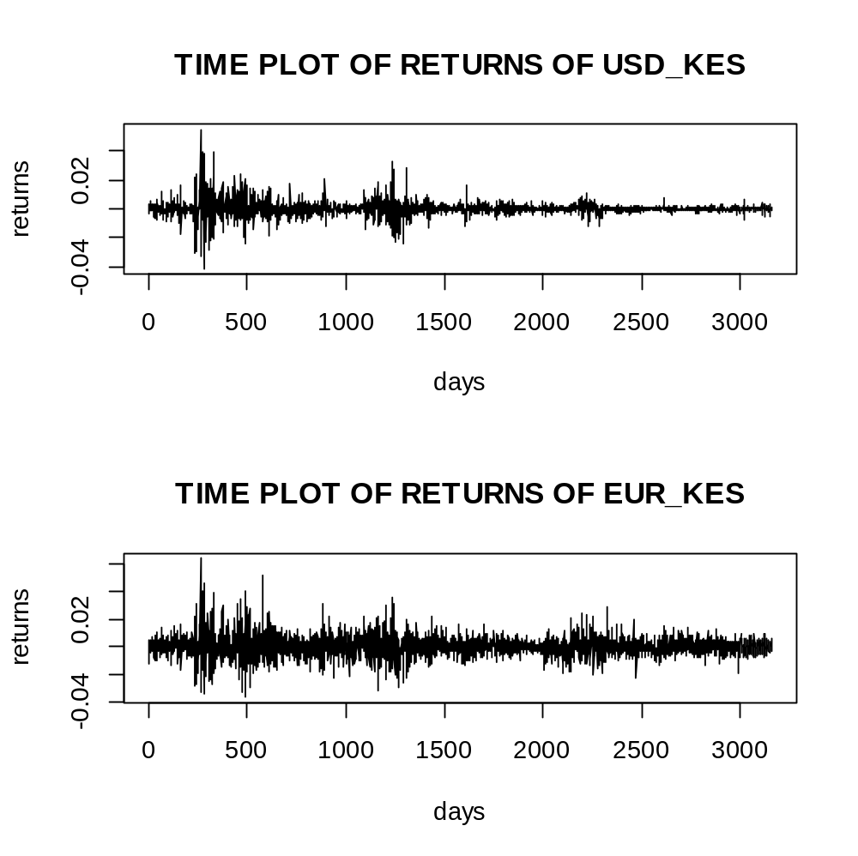
Figure 4. 4 Time plots of returns
Here we observe volatility clustering phenomena hence introducing heteroskedastic characteristic of financial time series and presence of stationarity which was confirmed by the plot of ACF of the returns and the Augmented dickey fuller test.

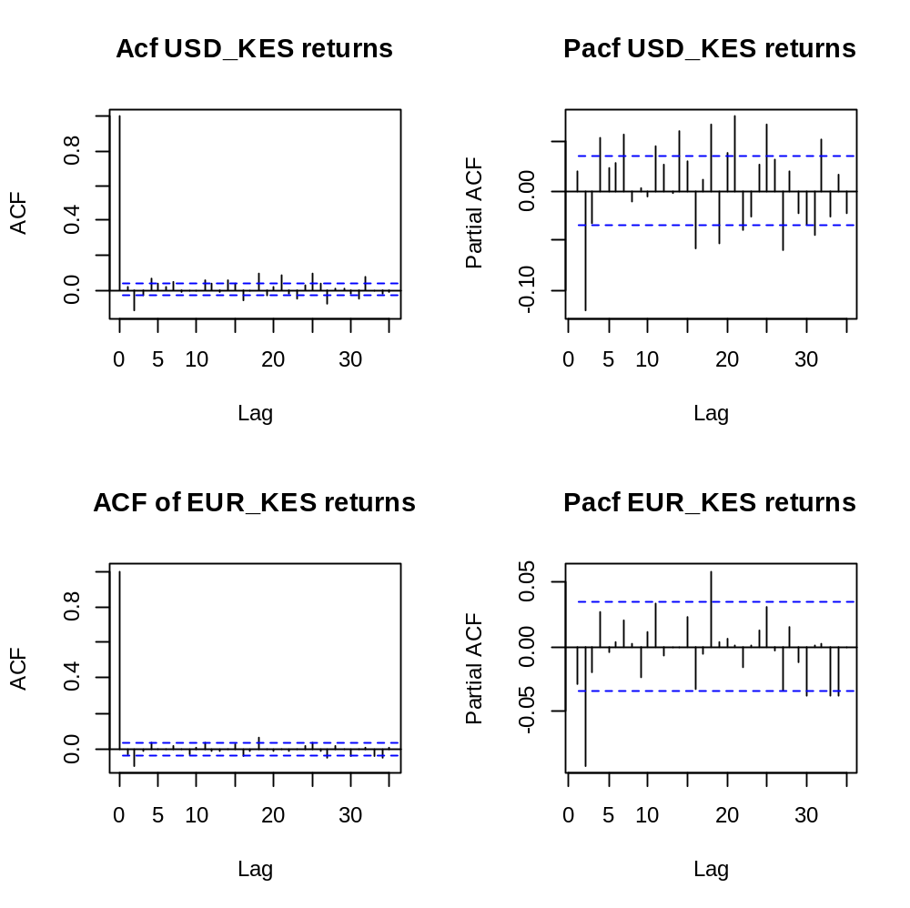
Figure 4. 5 ACF and PACF of the returns
The ACF and PACF stabilized on differencing once indicating that the data tends to stabilize after the single differencing of logs. As a confirmation of stationarity the ADF test was conducted once more and the results obtained as follows:
Augmented dickey fuller test on the USD_KES returns:
Hypothesis:
$H_{0}$:$α$=0(the USD-KES returns are not stationary/unit root)
$H_{1}$:$α$<0(the USD_KES returns is stationary/no unit root)
The test statistic is a t-statistic
t=$\frac{α}{s.e(α)}$
Critical value:
Table 4. 7 ADF Test on USD_KES returns
Augmented Dickey-Fuller Test
data: returns
Dickey-Fuller = -12.1, Lag order = 14, p-value=0.01
alternative hypothesis: stationary

Since the p value is less than the level of significance we rejected the null hypothesis and concluded that indeed the returns of USD_KES were stationary.
Augmented Dickey-Fuller Test on EUR_KES returns.
Hypothesis.
$H_{0}$:$α$=0(the EUR_KES returns are not stationary/unit root)
$H_{1}$:$α$<0(the EUR_KES returns is stationary/no unit root)
The test statistic is a t-statistic
t=$\frac{α}{s.e(α)}$

Table 4. 8 ADF test on EUR_KES Data
Augmented Dickey-Fuller Test
data: returnsse
Dickey-Fuller = -13.959, Lag order = 14,
p-value = 0.01
alternative hypothesis: stationary

Since the p value is less than the level of significance we rejected the null hypothesis and concluded that the returns of EUR_KES were stationary.

4.1 DESCRIPTIVE STATISTICS OF THE RETURN SERIES.
Further descriptive statistics on the returns were obtained as follows:
Table 4. 9 Descriptive statistics for USD_KES Returns
Statistic | Estimate
1.standard deviation | 0.002017044
2.mean | 0.0001062271
3.median | 0
4.kurtosis | 10.97397
5.skewness | -0.01253015

Table 4. 10 Descriptive statistics for EUR_KES data.
Statistic | Estimate
1.standard deviation | 0.005370083
2. mean | 1.830261e-05
3.median | 0.0000
4.kurtosis | 4.998519
5.skewness | 0.1584349

The results clearly indicates that the mean for both returns is approximately zero,skewness is a near normal distribution, that is,approximately zero but then kurtosis is greater than3 indicating that the returns exhibit a leptokurtic characteristic.On plotting QQ plots of the returns the following results were obtained:
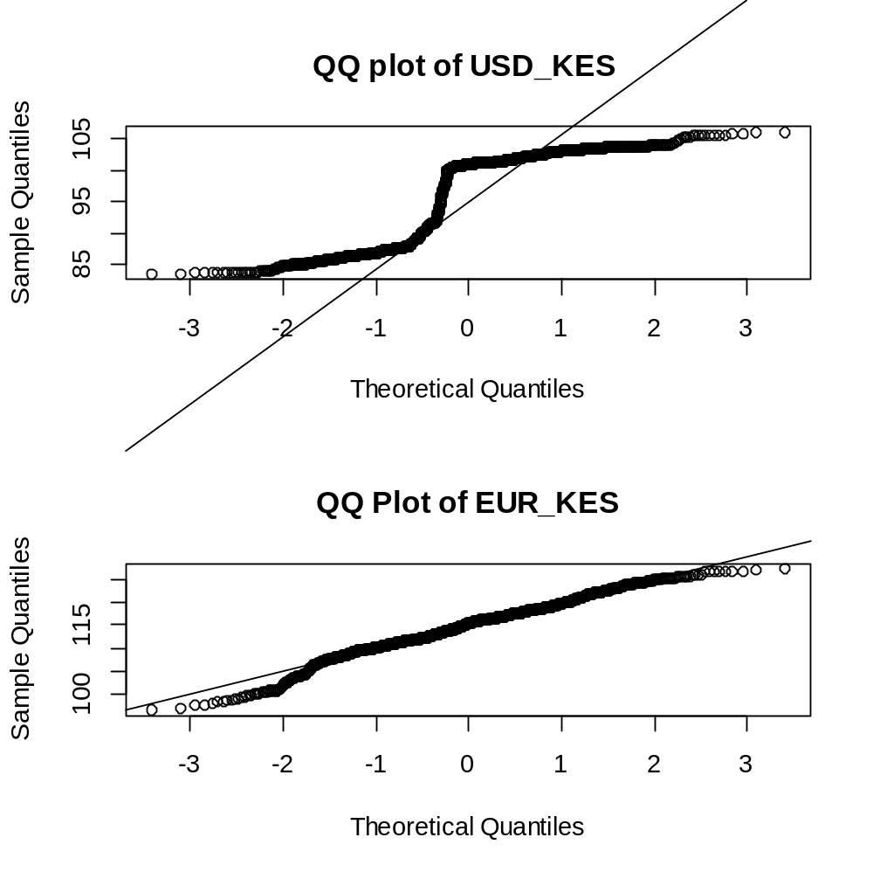
Figure 4.6 QQ Plots of data
On running a Shapiro Wilk’s test of normality indeed the results were:
Table 4. 11 Shapiro Wilk's test USD_KES returns
Shapiro-Wilk normality test
data: returnss
W = 0.89635, p-value < 2.2e-16

Table 4. 12 Shapiro Wilk's test for EUR_KES Returns
Shapiro-Wilk normality test
data: returnsse
W = 0.98075, p-value = 8.252e-14
this clearly shows that the returns are not normally distributed .All these are main characteristics of financial time series data returns.

4.2 ESTIMATING PARAMETERS AND FITTING THE E-GARCH MODEL TO THE FOREIGN EXCHANGE DATA.

4.2.1 THE ARIMA MODEL FITTING PROCEDURE
Using several combinations of ARIMA model’s for analysis ,the parameters that have least AIC,AICC and BIC were used for ARIMA and the following output obtained:
From the results of ACF and PACF of returns above it can easily be seen that the order of differencing is 1 since the returns achieved a unit root non-stationarity by differencing once.This illustrates that d=1.
Determinination of the MA-order from ACF and the AR-order from the PACF.
The plot of ACF for both returns was made again for the purposes of MA and AR order identification.
From the plots above the following can be deduced about the moving average (MA) order and Autoregressive model (AR) order. The following table displays the possible orders of Autoregressive and Moving average orders from PACF and ACF respectively.

4.2.2 FITTING AN ARIMA MODEL.
Using several combination models for analysis,the parameters that have the least AIC,AICC and BIC have the output below:
Table 4. 13 USD_KES ARIMA model fit
ARIMA (2, 1, 2) with drift.
Coefficients:
ar1 ar2 ma1 ma2 drift
0.2596 -0.3814 -0.2218 0.2785 0.0103
s.e. 0.1752 0.1076 0.1826 0.1100 0.0062
sigma^2 estimated as 0.1389: log likelihood=-1364.06
AIC=2740.12 AICc=2740.15 BIC=2776.48
>
The fitted model
$R_{t(usd_{kes})}$=0.2596$R_{t-1}-$ 0.3814 $R_{t-2}$+$e_{t}-$0.2785 $e_{t-1}-$0.0103$e_{t-2}$

Table 4. 14 EUR_KES ARIMA Model fit
Series: EUR_KES
ARIMA(2,1,0)
Coefficients:
ar1 ar2
-0.0261 -0.0822
s.e. 0.0177 0.0177
sigma^2 estimated as 0.6791: log likelihood=-3875.07
AIC=7756.13 AICc=7756.14 BIC=7774.31
The fitted model:
$R_{t(EUR_{KES})}$=-0.0261$R_{t-1}-$ 0.0822$R_{t-2}$+$e_{t}$.
Before the models were used for forecasting, they were checked for adequacy. On doing diagnostics the ACF and the PACF of the residuals were confirmed to be generally insignificant as shown:
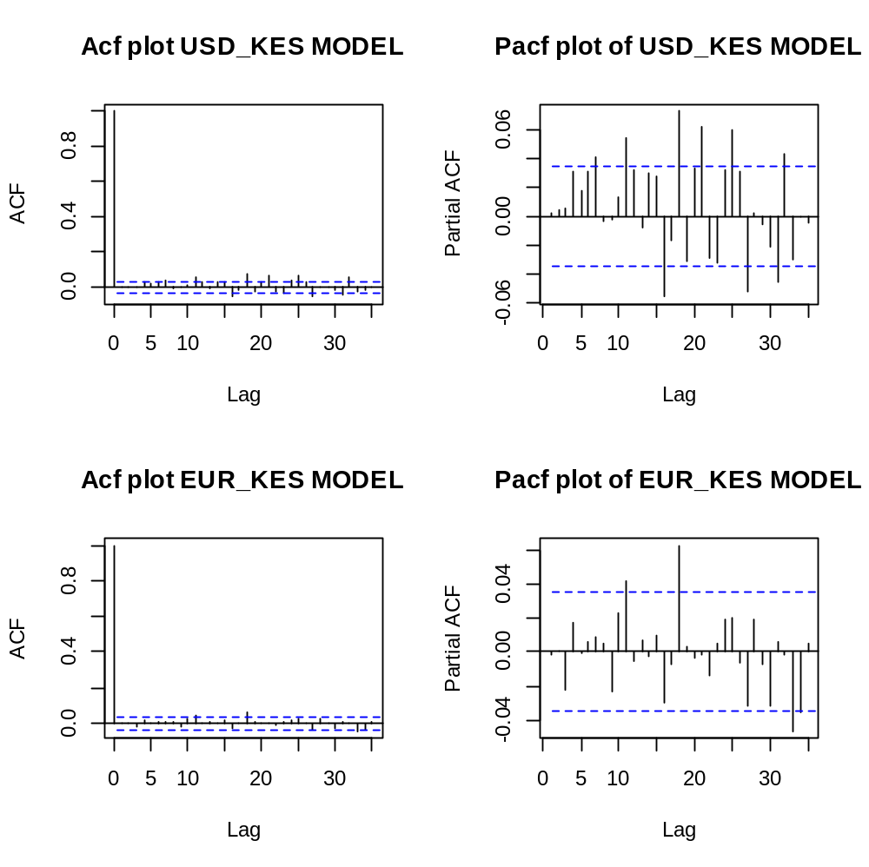
Figure 4.7 ACF and PACF Plots of the residuals
The test of autocorrelation was also done by carrying out an Ljung-box test.
The following hypothesis was tested:
$H_{o}$:the model fits the returns well.
$H_{a}$ :the model does not fit returns well.
Where lag h was obtained as ln(n)
Therefore ln(3164)=8
Test statistic:
The test statistic is shown in the following output:
Table 4. 15 L-Jung Box test for USD_KES ARIMA Model
Box.test(residuals(model.usd),type="Ljung",lag=8)
Box-Ljung test
data: residuals(model.usd)
X-squared = 12.828, df = 8, p-value = 0.1179

Table 4. 16 L-Jung box test for EUR_KES ARIMA Model
Box. Test(residuals(model),type="Ljung”, lag=8)
Box-Ljung test
data: residuals(model.eur)
X-squared = 2.8979, df = 8, p-value = 0.9406

In both cases it was clear that the p-value was greater than 0.05 hence we failed to reject the null hypothesis concluding that the models fitted both USD_KES data and EUR_KES data well.
Generally, a model is adequate if the residuals left over after fitting the model are simply white noise. The study could now conclude that it is a good fit .The standardized residuals however indicated volatility clustering ,that is, period of low volatilities being followed by periods of high volatilities and vice-versa.

If time series values are truly independent, then nonlinear instantaneous transformations such as taking absolute values or squaring preserve independence. However, the same is not true of correlation, as correlation is only a measure of linear dependence. Higher-order serial dependence structure in data can be explored by studying the autocorrelation structure of the absolute returns (of lesser sampling variability with less mathematical tractability) or that of the squared returns (of greater sampling variability but with more manageability in terms of statistical theory). If the returns are independently and identically distributed, then so are the absolute returns (as are the squared returns), and hence they will be white noise as well. The Variance is 2.269213e-05, 5.685329e-05and mean 0.0001062271 and 1.830261e-05 the mean is not statistically significantly different from zero. However, the volatility clustering observed in the return data (standardized residuals)) gives us a hint that they may not be independently identically distributed otherwise the variance would be constant over time.
Then diagnostic of the residual returns was done and the results obtained as follows:
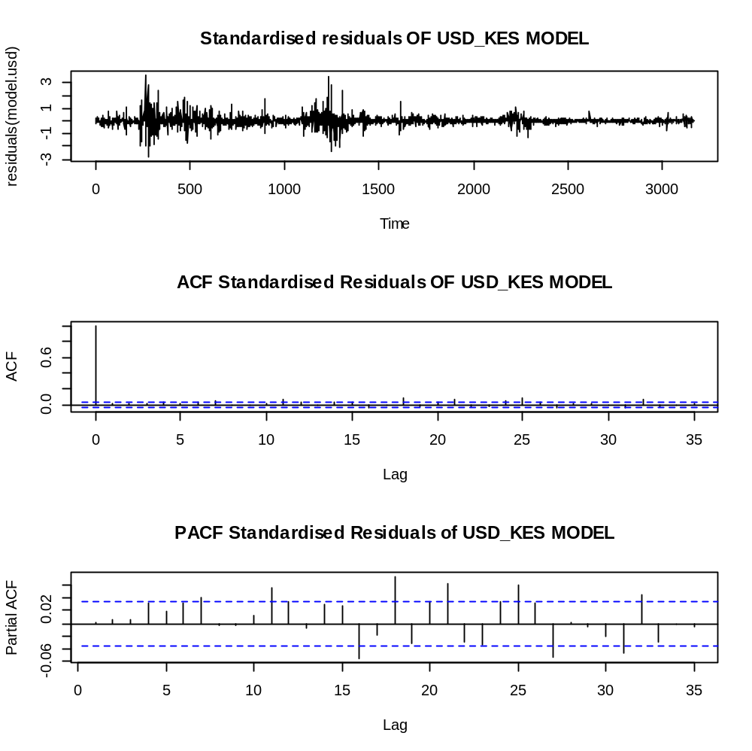
Figure 4. 9 Diagnostic plots of the standardized residuals of USD_KES Returns
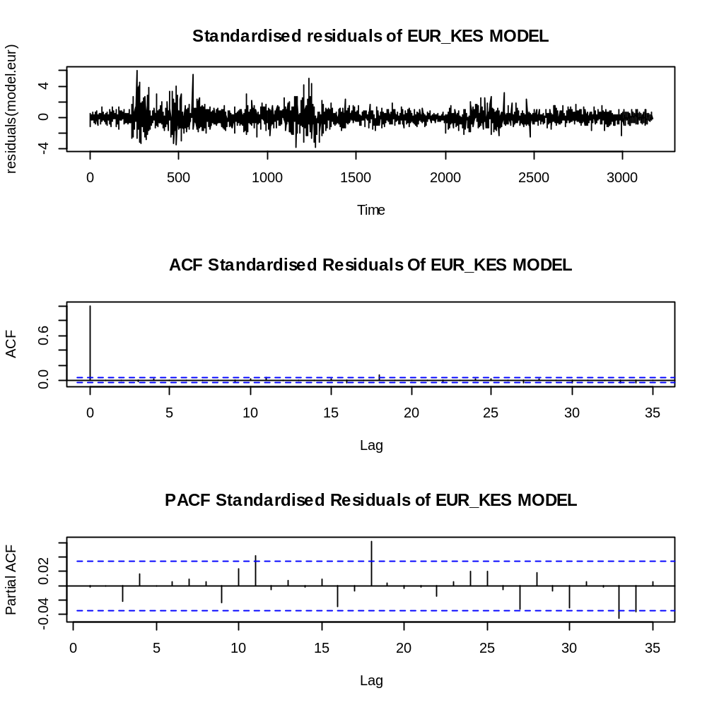
Figure 4. 10 Plots of standardized residuals of EUR_KES Returns
The given output was then observed after squaring the residuals and the ACF became significant as shown that is checking for characteristics that allude high-order dependency:

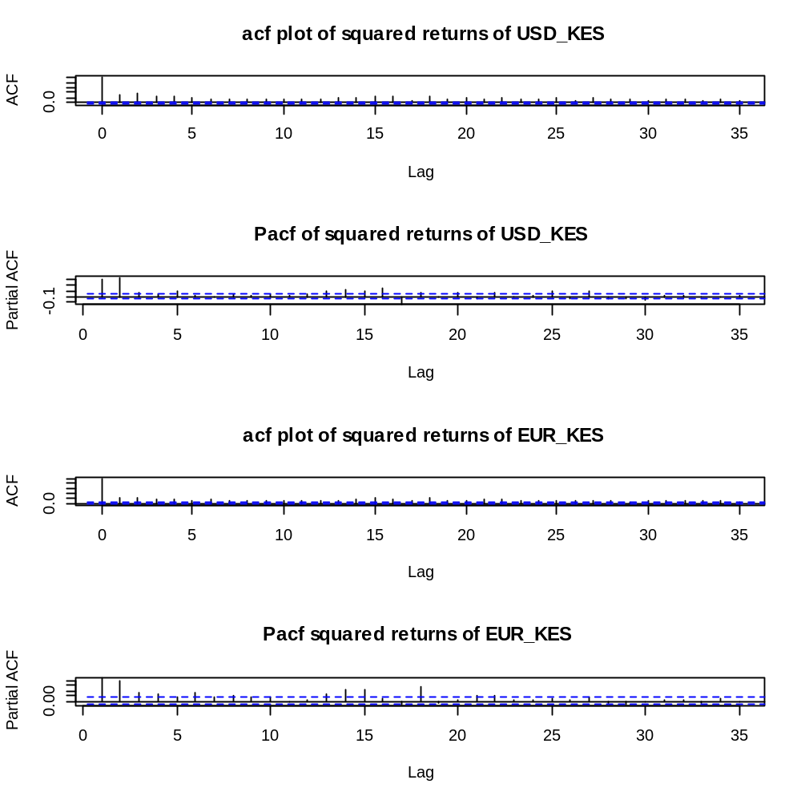
Figure 4. 11 ACF and PACF of the squared residuals
The ARIMA model major on the conditional mean structure of the time-series data. However, there are cases where there exist inconsistencies between the data and after transformation as shown. Above.
The ACFs show several characteristics, which have several inconsistencies. I hat is, if we take the squares of the returns and also take absolute values, the ACFs become significant. All the returns with the various transformations are supposed to indicate white noise characteristics, but that is not the case here! Hence, if the transformations of the returns admit some significant autocorrelations, then these autocorrelations furnish some evidence against the hypothesis that the returns are i.i.d. These plots indicate the existence of significant autocorrelation patterns in the absolute and squared data and indicate that the returns are in fact serially dependent
Further analysis on the residuals using Shapiro-Wilk’s normality test under the normality assumption indicate
Table 4. 17 Shapiro wilk's test of normality of residuals
shapiro.test(residuals(model.usd))
Shapiro-Wilk normality test
data: residuals(model.usd)
W = 0.79247, p-value < 2.2e-16
> shapiro.test(residuals(model.eur))
Shapiro-Wilk normality test
data: residuals(model.eur)
W = 0.94156, p-value < 2.2e-16

In both models the p-value<0.05 hence we reject the hypothesis that the residuals are normally distributed at 95% confidence
In summary, the returns are found to be serially uncorrelated but admit a higher- order dependence structure, namely volatility clustering, and a heavy-tailed distribution.
This calls for a test for the ARCH-EFFECTS.

Testing for Conditional Heteroscedacity.
The hypothesis to be tested included:
$H_{0}$: There is no ARCH effect.
$H_{1}:$ There is an ARCH effect.
Test statistic was given by:
Q= N (N+2)$\sum_{k=1}^{m}{\frac{ρ_{k}^{2} }{N-K}}$
The test statistic is compared with chi-square tabulated value with (m-p-q) degrees of freedom. Consequently, the null hypothesis will be rejected if p-value<$α$
Where $α$=level of significance.
N=sample size.
m=number of autocorrelation included in the statistic.
$ρ_{k}^{2}$=sample autocorrelation of residuals series$\left\{e_{i}\right\}$ at lag k.
The results were as shown below:
Table 4. 18 Test of ARCH effects
Box-Ljung test
data: (modelusd.residuals)^2
X-squared = 254.92, df = 1, p-value < 2.2e-16

Box-Ljung test
Data: (model.eur. Residuals)^2
X-squared = 171.15, df = 1, p-value < 2.2e-16
In both cases the null hypothesis was rejected since the p-value was less than 0.05 implying presence of the ARCH effects.

4.2.3 FITTING GARCH (1, 1) MODEL.
The results for the fitted GARCH model was as follows:
Table 4. 19 GARCH Fit for USD_KES
garchfit.usd@fit$coef
mu ar1 ar2 ma1 omega
6.970288e-05 3.429483e-01 -1.191135e-03 -4.079401e-01 -3.858693e-02
alpha1 beta1 gamma1
5.330398e-03 9.947331e-01 2.256652e-01

Table 4. 20 GARCH Fit for EUR_KES
garchfit.eur@fit$coef
mu ar1 ar2 ma1 omega
-9.404933e-06 1.718320e-01 -3.892981e-02 -2.292359e-01 -3.932644e-02
alpha1 beta1 gamma1
-6.431483e-03 9.956239e-01 1.118752e-01

Sign bias test on GARCH model
Then the next step was to establish whether there is asymmetric effects in the data set using the Sign bias test as shown below:
Table 4. 21 Sign bias on USD_KES GARCH Model
Sign Bias Test
------------------------------------
t-value prob
Sign Bias 0.01946 0.08457
Negative Sign Bias 0.012003 0.02301
Positive Sign Bias 0.08519 0.03943
Joint Effect 0.0 21796 0.005360
Table 4. 22 Sign bias test for EUR_KES GARCH Model
Sign Bias Test
------------------------------------
t-value prob
Sign Bias 0.009523 0.03410
Negative Sign Bias 0.006857 0.04930
Positive Sign Bias 1.0251 0.03054
Joint Effect 3.7860 0.02855
In the two cases above, it is clear that the Asymmetric effects of negative and positive shocks have not been captured well by the fitted GARCH (1, 1) model. Therefore, the study resulted in proceeding to Asymmetric GARCH since GARCH does not fit these data well.

4.2.4 FITTING THE E-GARCH MODEL.
The E-GARCH model was fitted and the output obtained as follows:
Table 4. 23 USD_KES E-GARCH Fit
egarchfit.usd@fit$coef
mu ar1 ar2 ma1 omega
6.970288e-05 3.429483e-01 -1.191135e-03 -4.079401e-01 -3.858693e-02
alpha1 beta1 gamma1
5.330398e-03 9.947331e-01 2.256652e-01

Table 4. 24 EUR_KES E-GARCH Fit
egarchfit.eur@fit$coef
mu ar1 ar2 ma1 omega
-9.404933e-06 1.718320e-01 -3.892981e-02 -2.292359e-01 -3.932644e-02
alpha1 beta1 gamma1
-6.431483e-03 9.956239e-01 1.118752e-01

4.3 STUDYING THE PROPERTIES OF THE FITTED MODEL

4.3.1 VOLATILITY
To check whether the model was correctly specified, the standardized residuals were examined whether they were close to iid by examining the ACF .The plots of the ACF of returns, squared and absolute standardized residuals from E-GARCH (1, 1) model as shown:

Using USD_KES data.

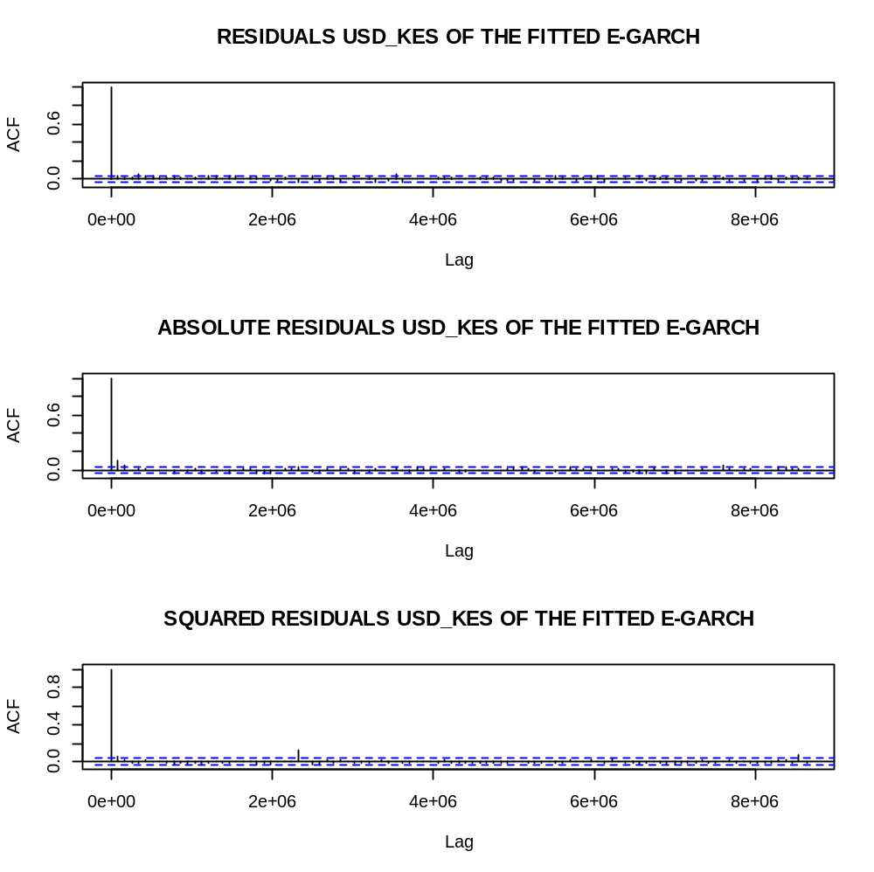
Figure 4. 12 ACF Plots of residuals of fitted USD_KES E-GARCH Model

Using EUR_KES data.
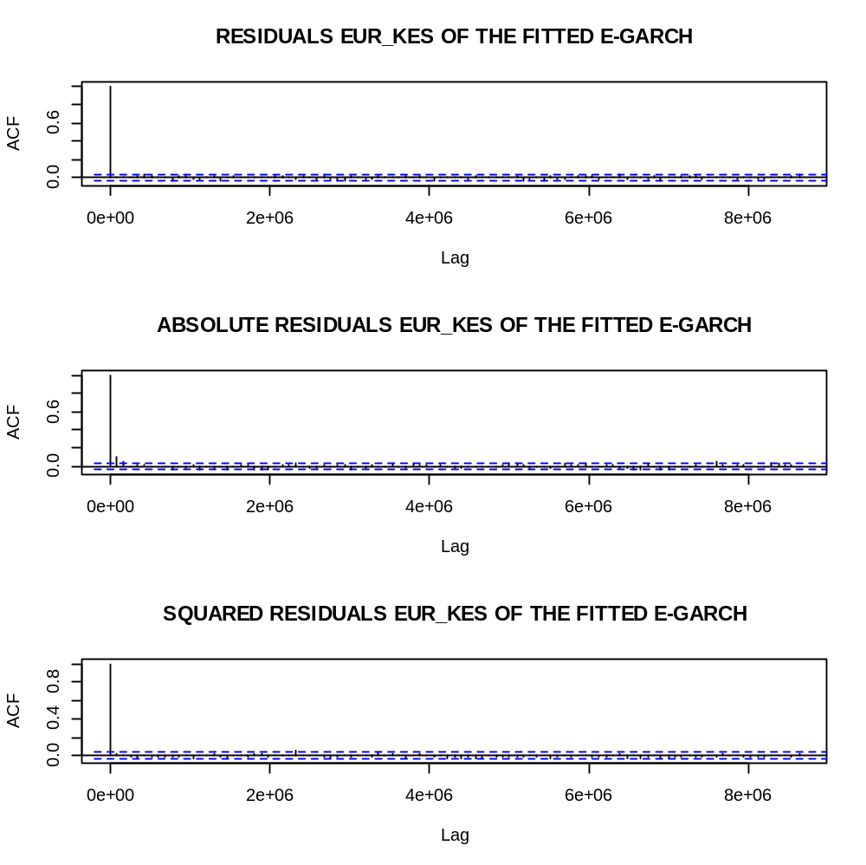
Figure 4. 13 ACF Plots of residuals of fitted EUR_KES E-GARCH Model

The results above show that in both cases the squared and absolute residuals are serially uncorrelated.
This could be reinforced by conducting a L-Jung box test (portmanteau test) which performs goodness of fit test for the E-GARCH model by checking whether standardized residuals are iid based on the ACF of absolute residuals or squared residuals(chan,2008). The figure below displays the portmanteau tests: Using USD_KES fitted E-GARCH MODEL.

Table 4. 25 Box L-Jung test USD_KES E-GARCH MODEL
Box-Ljung test
data: model.residual.squared
X-squared = 21.946, df = 20, p-value =0.3434

Table 4. 26 Box L-Jung test for EUR_KES E-GARCH Model
Box-Ljung test
data: model2.residuals
X-squared = 16.152, df = 20, p-value =0.7072

Clearly in both cases the p-values are greater than 0.05 hence indicating that the E-GARCH models fits both data well.
This now allowed the study to predict volatilities and prices as shown below.

4.3.4 THE SIGN BIAS TEST.

Table 4. 27 USD_KES E-GARCH Model Sign bias Test
Sign Bias Test
------------------------------------
t-value prob
Sign Bias 0.1946 0.8457
Negative Sign Bias 1.2003 0.2301
Positive Sign Bias 0.8519 0.3943
Joint Effect 2.1796 0.5360

Table 4. 28 EUR_KES E-GARCH Model Sign bias Test
Sign Bias Test
------------------------------------
t-value prob
Sign Bias 0.9523 0.3410
Negative Sign Bias 0.6857 0.4930
Positive Sign Bias 1.0251 0.3054
Joint Effect 3.7860 0.2855

Since in both cases the Joint Effect p-value is greater than 0.05 it means that Asymmetry is statistically insignificant therefore, implying that the E-GARCH model has been able to capture this feature.

4.3.5 NORMALITY
As a way of validating the distribution of the residuals whether they were indeed white noise the plot of the density of residuals of the fitted E-GARCH model were obtained as follows:
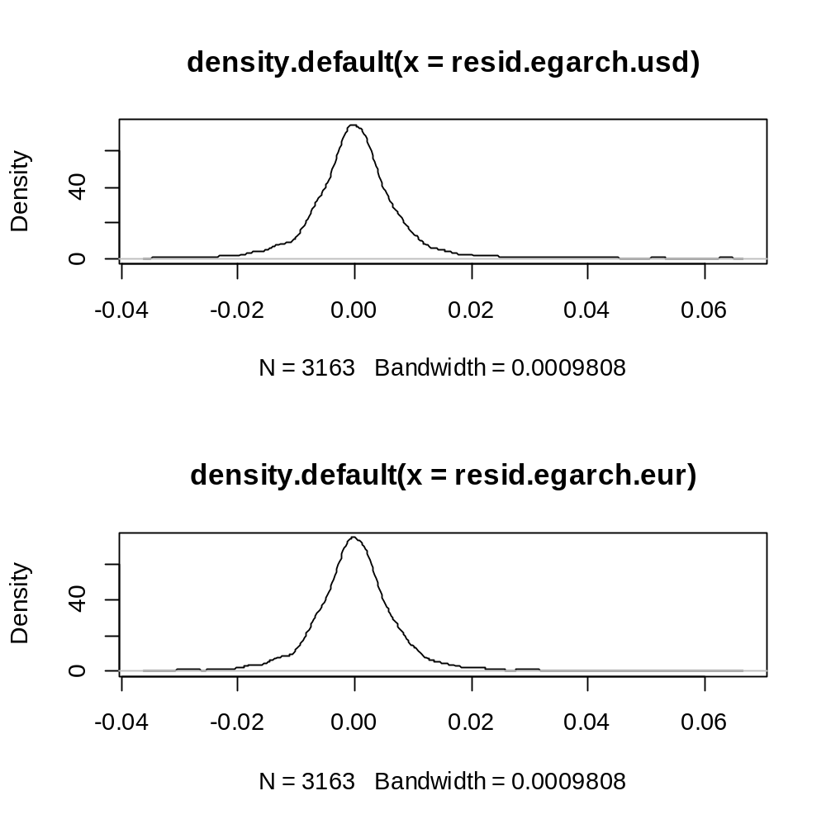
Figure 4. 14 Density plots of the Residuals
It was clear that the mean of the residuals in both cases was approximately zero and the density resembled a normal distribution as confirmed by the QQ-plots below:
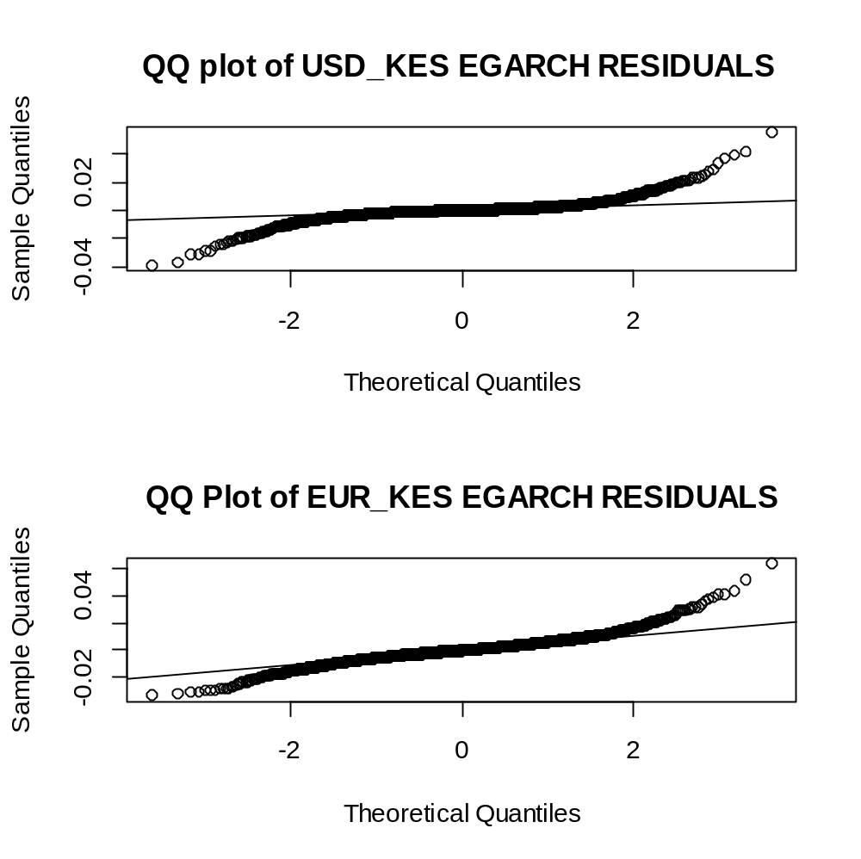
Figure 4. 15 QQ Plots of the residuals of the E-GARCH Models
The residuals were normal in distribution as shown by the above plots since most points lie on the vertical line.

4.4 MULTI-STEP AHEAD FORECAST OF FOREIGN EXCHANGE USING THE E-GARCH MODEL.
Given the fitted E-GARCH (1, 1) model to the currency exchange data. We may use it to forecast future mean and conditional variances given the asymmetric nature of the data. We can predict using 25% of the sample data obtained from investing.com website as the actual data. This implies that

$\frac{25}{100}$*3165=792.
The study considered 792 multiple ahead forecasts using the fitted model and the results compared to the actual values as shown in the output below:

As displayed above it is very clear that the predicted values and the actual values are very close therefore, this tries to illustrate that the model is very reliable in forecasting future exchange rates.

Forecast of the in-sample
Using usd_kes data:
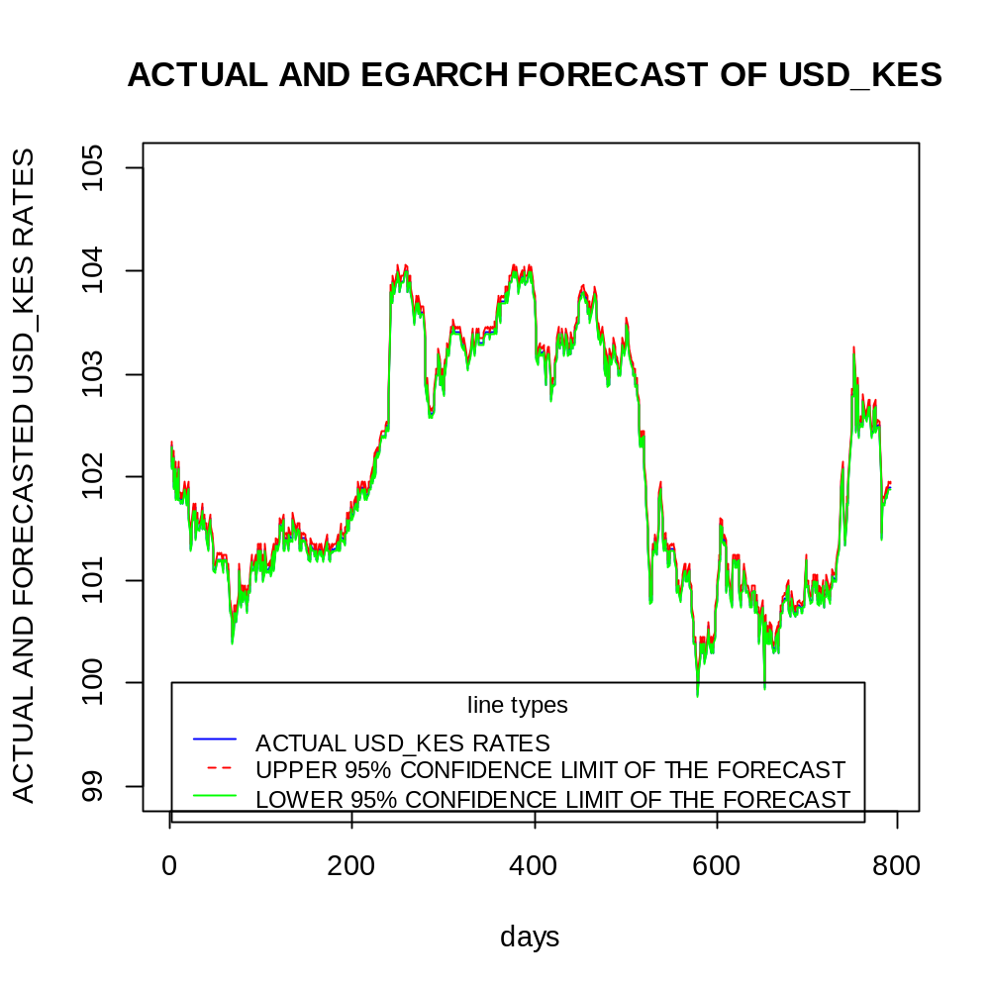
Figure 4. 16 In sample forecast plots for USD_KES

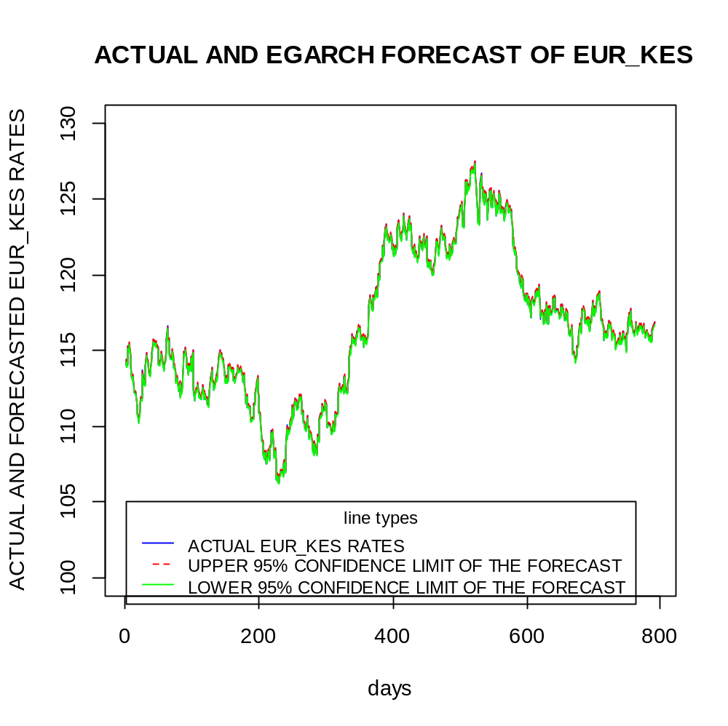
Figure 4. 17 In sample Forecast plots for the EUR_KES

Out of sample forecasts.
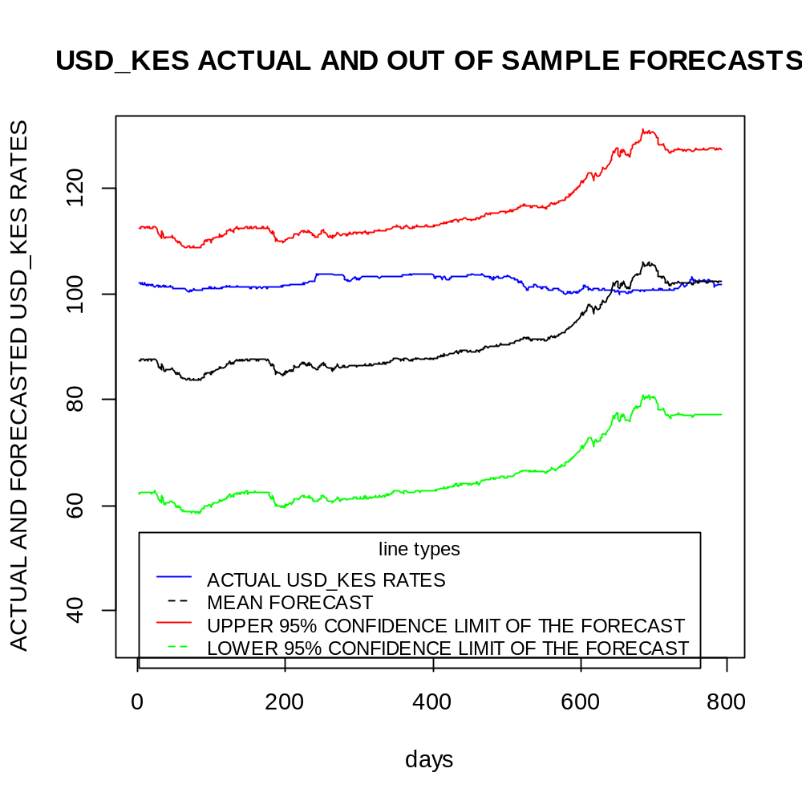
Figure 4. 18 Out of sample Forecast for USD_KES

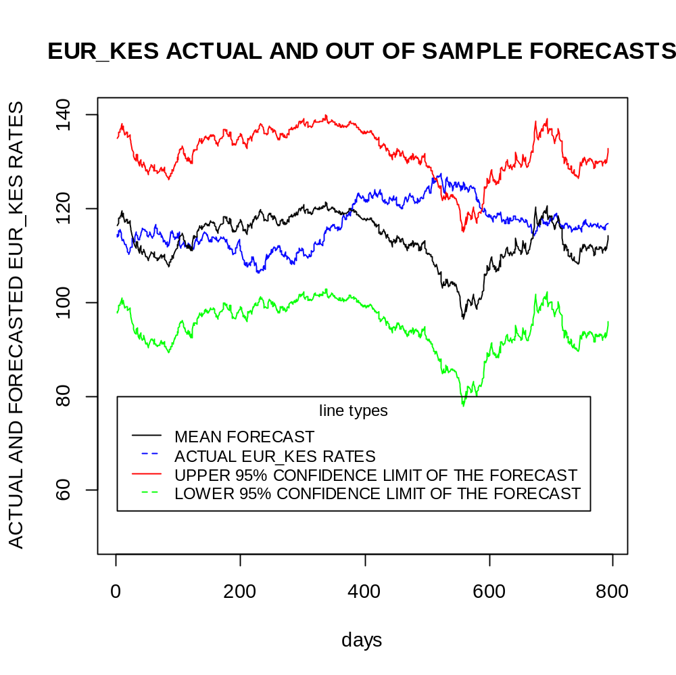
Figure 4. 19 Out of sample forecast for EUR_KES
Clearly, in both cases the actual exchange rates lies within the upper and the lower confidence interval of the forecasts. This illustrates that the model is reliable for out of sample forecasting.

In an attempt to look at the similarities between the forecasted values and the predicted values the boxplot of both the actual values and the predicted values was made and the following output obtained.
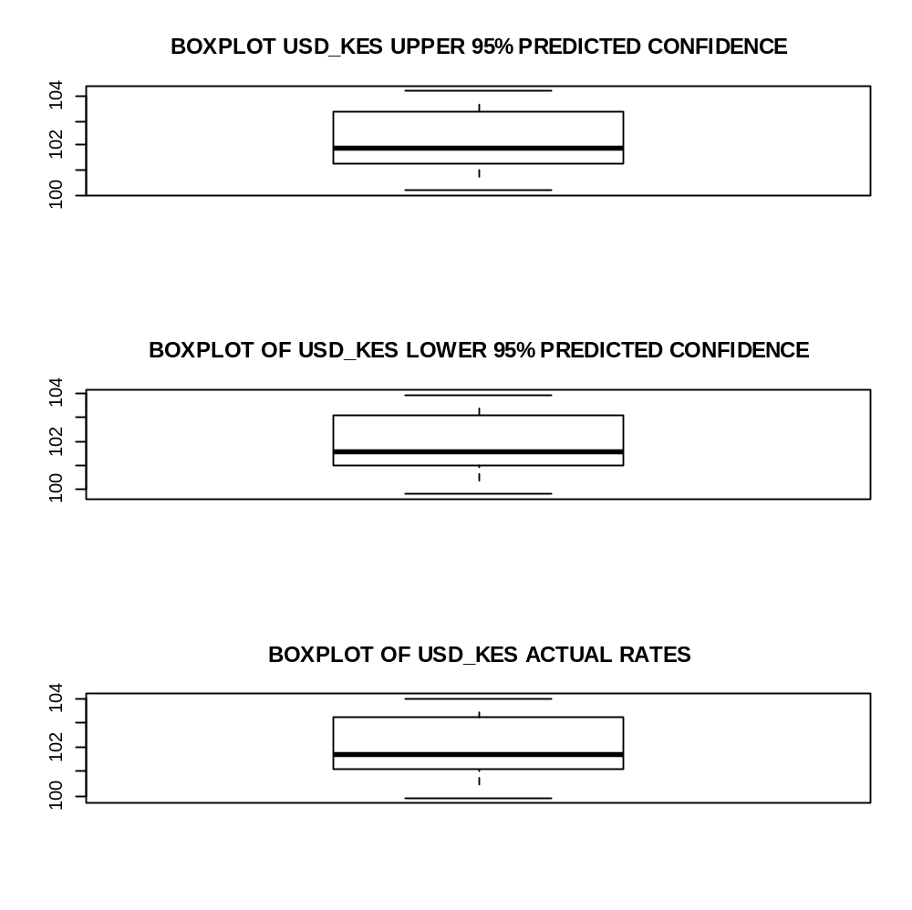
Figure 4. 20 Box plots of forecasted Confidence and the Actual USD_KES
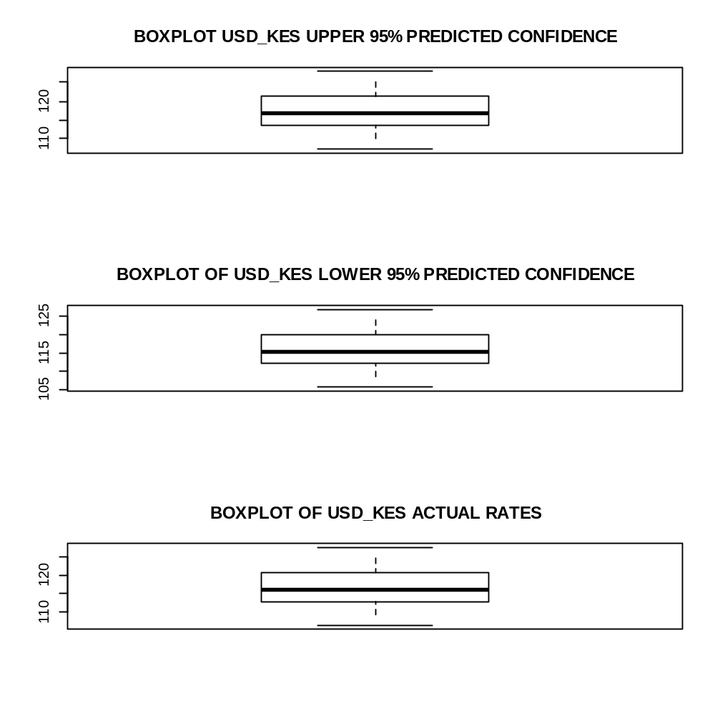
Figure 4. 21 Box plots of forecasted Confidence and the Actual EUR_KES
It is very clear that the mean of the predicted values is almost equal to the actual whereby the following inference was made:
Table 4. 29 Comparison of predicted and actual
Currency pair | Forecasts(mean) | Actual(mean)
USD_KES | Upper limit: 102.2153  Lower limit: 101.9133 | 102.036
EUR_KES | Upper limit: 117.047  Lower limit: 115.8596 | 116.4689
This shows that the model has been able to capture the actual mean accurately because it lies within the interval.

4.4.1VALIDATION OF THE DISTRIBUTION OF THE FORECASTED AND THE ACTUAL EXCHANGE RATES.
USING USD_KES
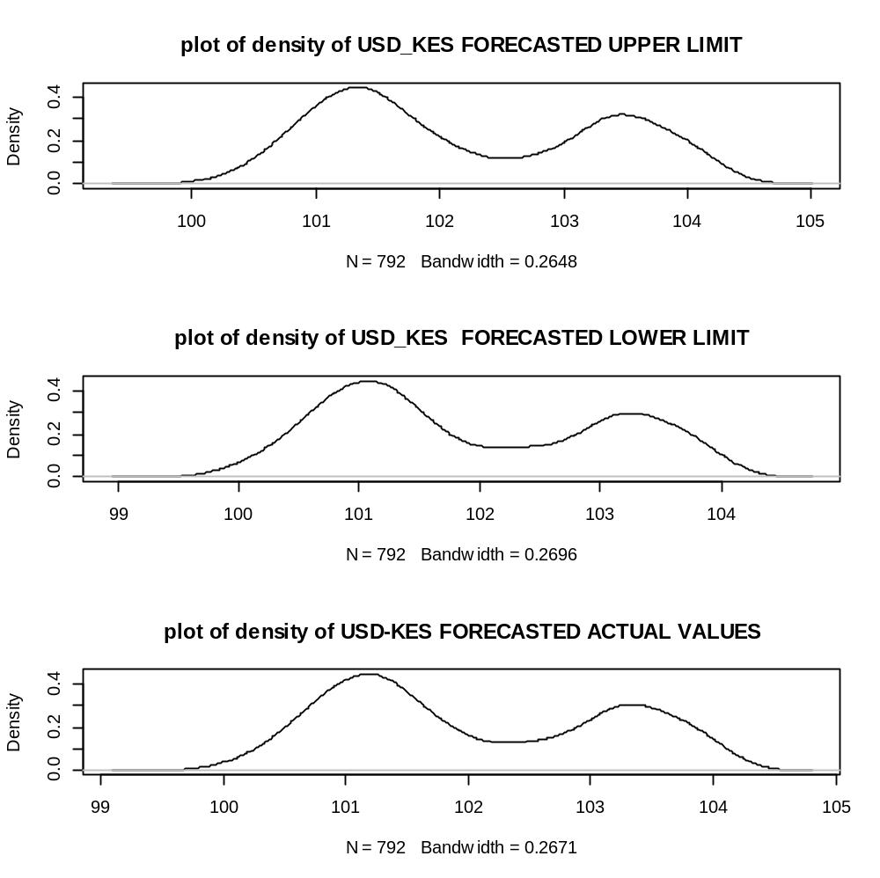
Figure 4. 22 Density plots of forecasted and actual USD_KES

USING EUR_KES.

This proofs that the distribution is similar and therefore it tries to proof that the model gives an almost similar rates to the actual rates.
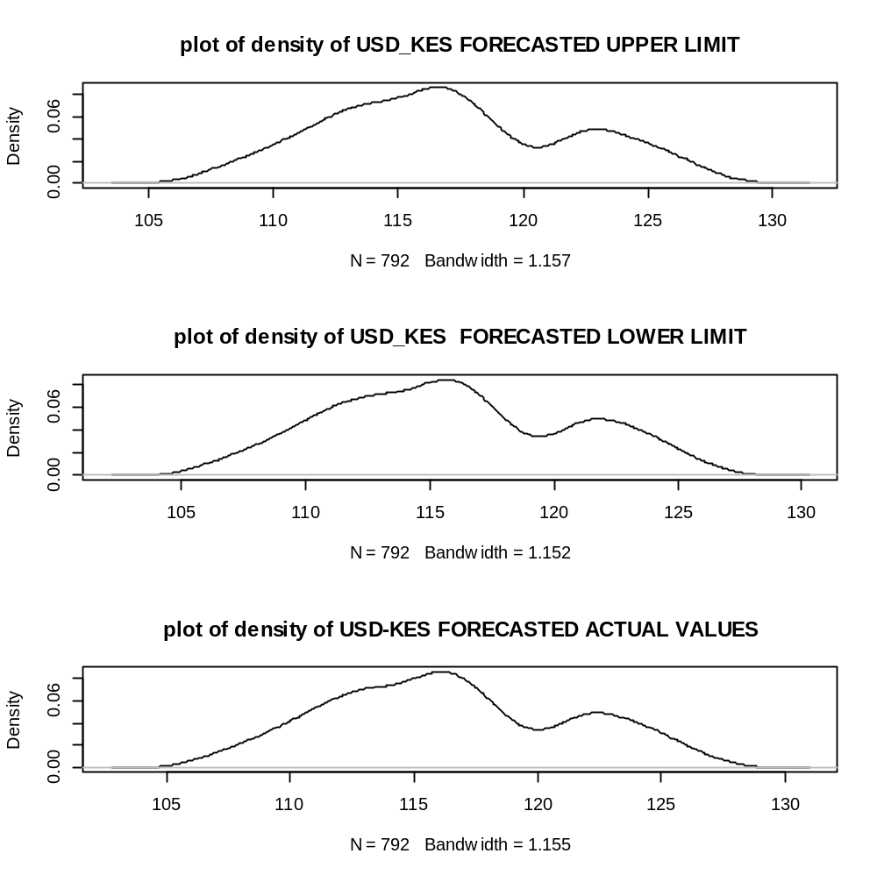
Figure 4. 23 Density plots of forecasted and actual EUR_KES

4.5 TESTING THE FORECASTING P0WER OF THE FITTED MODEL
There are performance metrics proposed by literature to review the forecasting performance of a given model. The following were taken in to consideration:
Then the following performance metrics were computed:
Table 4. 30 Forecasting Performance metrics
CURRENCY PAIRS | PERFORMANCE METRIC | VALUE OF THE METRIC USING LOWER FORECAST CONFIDENCE | VALUE OF THE METRIC USING UPPER FORECAST CONFIDENCE
USD_KES | Mean forecast error(MFE) | 0.1231322 | -0.1792384
 | Mean absolute error(MAE) | 0.1231322 | 0.1792384
 | Mean absolute percentage error(MAPE) | -0.1757991 | 0.1207928%
EUR_KES | Mean forecast error  (MFE) | 0.6074666 | -0.5814596
 | Mean absolute percentage error(MFE) | 0.6074666 | 0.5814596
 | Mean absolute percentage error(MAPE) | 0.5219535 | -0.5000159

CHAPTER FIVE

CONCLUSION.
From the analysis generated from this study, it has emerged that EGARCH
Model is the best model for modelling foreign exchange data which are highly prone to asymmetric effects. EGARCH (1,1) model can better forecast these data compared to GARCH (1,1) model. It is also noteworthy to state that the model has satisfied all the conditions which include stationary conditions, absence of ARCH effect and random and independently distributed residuals. Furthermore, the model exhibit a normal distribution as exhibited in the QQ plot. The study has presented us with the opportunity to have a deeper understanding of the theory of time series analysis and its application to real life situation. It is clear from the study that the foreign currency exchange rates rate data series is characterized with spikes, variations and trends, hence EGARCH model serves as the best in forecasting foreign exchange data.

RECOMMENDATION
The study would recommend further research on modeling foreign exchange data using a multivariate Arch-type models where other variables that have influence on currency exchange are incorporated. The study would also recommend further research on modeling of performance of Nairobi Stock Exchange using EGARCH model.

WORK PLAN

The grant chart below will be used to show our work plan throughout the study
Weeks  Activities | Week1-2 | Week3-4 | Week 5-6 | Week 7-8 | Week8-9 | Week 9-10 | Week11-12
Preliminary work
Consultation with lecturer
Proposal writing
Proposal presentation
Data
Analysis
Documentation
Project presentation

BUDGET
Item name | Unit | Cost (ksh) | Total amount(ksh)
Printing | 1 | 5000 | 5000
Internet fee |  | 1500 | 1500
Stationary (pens, books, rubbers, rim papers) |  | 800 | 800
Fare |  | 2000 | 2000
Miscellaneous |  | 1000 | 1000
Total cost |  |  | Ksh 10,300

REFERENCES.
New Jersey, (1980), Day Trading and Swing Trading the Currency market, Lien Kathy, ed. Day trading the currency market.

Central Bank of Kenya (2008). URL: http://www.centralbank.go.ke/l A_Qs/ MonetarvPolievFAOs.aspx., accessed 17th July 2011.
(Bollerslev, Engle, & Nelson, 1994b)Adebiyi, A. A., Adewumi, A. O., & Ayo, C. K. (2014). Stock price prediction using the ARIMA model. In Proceedings - UKSim-AMSS 16th International Conference on Computer Modelling and Simulation, UKSim 2014. https://doi.org/10.1109/UKSim.2014.67
Appiah, S.T, & Adetunde, I. . (2011). Forecasting Exchange Rate Between the Ghana Cedi and the Us Dollar Using Time Series Analysis. African Journal of Basic and Applied Sciences.
Bandyopadhyay, G. (2016). Gold Price Forecasting Using ARIMA Model. Journal of Advanced Management Science, 117–121. https://doi.org/10.12720/joams.4.2.117-121
Bollerslev, T. (1986). Generalized autoregressive conditional heteroskedasticity. Journal of Econometrics. https://doi.org/10.1016/0304-4076(86)90063-1
Bollerslev, T., Engle, R. F., & Nelson, D. B. (1994a). Arch models. In Handbook of econometrics. https://doi.org/10.1016/S1573-4412(05)80018-2
Bollerslev, T., Engle, R. F., & Nelson, D. B. (1994b). Chapter 49 Arch models. Handbook of Econometrics. https://doi.org/10.1016/S1573-4412(05)80018-2
Box, G. E. P. (1976). Science and statistics. Journal of the American Statistical Association. https://doi.org/10.1080/01621459.1976.10480949
Engle, R. F. (1982a). Autoregressive Conditional Heteroscedasticity. Econometrica.
Engle, R. F. (1982b). Autoregressive Conditional Heteroscedasticity with Estimates of the Variance of United Kingdom Inflation. Econometrica. https://doi.org/10.2307/1912773
Friedman, B. M., & Kuttner, K. N. (1992). Money, Income, Prices, and Interest Rates. American Economic Review. https://doi.org/10.2307/2117316
Kilian, L., & Taylor, M. P. (2003). Why is it difficult to beat the random walk forecast of exchange rates? Journal of International Economics. https://doi.org/10.1016/S0022-1996(02)00060-0
Mark, N. C., & Sul, D. (2001). Nominal exchange rates and monetary fundamentals. Evidence from a small post-Bretton woods panel. Journal of International Economics. https://doi.org/10.1016/S0022-1996(00)00052-0
Nelson, D. B., & Cao, C. Q. (1992). Inequality constraints in the univariate garch model. Journal of Business and Economic Statistics. https://doi.org/10.1080/07350015.1992.10509902
Taylor, M. P., & Peel, D. A. (2000). Nonlinear adjustment, long-run equilibrium and exchange rate fundamentals. Journal of International Money and Finance. https://doi.org/10.1016/S0261-5606(99)00044-3
Taylor, M. P., Peel, D. A., & Sarno, L. (2001). Nonlinear mean-reversion in real exchange rates: Toward a solution to the purchasing power parity puzzles. International Economic Review. https://doi.org/10.1111/1468-2354.00144
Tseng, F. M., Tzeng, G. H., Yu, H. C., & Yuan, B. J. C. (2001). Fuzzy ARIMA model for forecasting the foreign exchange market. Fuzzy Sets and Systems. https://doi.org/10.1016/S0165-0114(98)00286-3
Jurgen Franke, e. a. (2008). Statistics of Financial Markets: An introduction. Berlin: Springer-Verlag

